

SG/di 658
13 de septiembre de 2004
4.37.52

ACUERDO DE PARTENARIADO
OECD, Metagora - CAN

ORGANISATION DE COOPÉRATION ET DE DÉVELOPPEMENT ÉCONOMIQUES
OECD OCDE

ORGANISATION FOR ECONOMIC CO-OPERATION AND DEVELOPMENT
PARTNERSHIP AGREEMENT
Between
The Organisation for Economic Co-operation and Development, whose headquarters are situated at 2 rue André Pascal, 75775 Paris Cedex 16, France, represented by Mr Anthony C. Hutton, Executive Director, hereinafter referred to as "the OECD"
ON THE ONE HAND
and
Secretaría General de la Comunidad Andina, whose headquarters are situated at Paseo de la Republica 3895, Lima 27, Peru, represented by Allan Wagner Tizón, Secretario General, hereinafter referred to as "the Partner organisation"
ON THE OTHER HAND
WHEREAS, the OECD and- the Partner organisation will jointly carry out the METAGORA pilot Project - Measuring Democracy, Human Rights and Governance (hereinafter "the Project"). The principal objective of the Project is to develop and test pilot monitoring methods, measuring tools and indicators in the fields of Democracy, Human Rights and Governance;
WHEREAS, the funding for the Project is obtained through grants from France, Sweden, Switzerland and the European Community, represented by the Commission of the European Communities (hereinafter. "the EC"). The grant from the EC is provided under an agreement executed between the DECD, in its role as responsible organisation; and the EC (hereinafter "the EC Grant Agreement");
WHEREAS, the Terms of Reference of the Project that form an integral part of the EC Grant Agreement and that are enclosed herein as Annex III, stipulate that OECD, as responsible organisation will carry out METAGORA activities in partnership with seven selected institutions in charge of the implementation or coordination of selected pilot field operations and studies financed through the Project's budget. These Partner organisations are:
- American Association for the Advancement of Sciences, HAAS; Washington;
- Développement et insertion internationale, DIAL, Paris;
- Fundar, Centro de Análisis e Investigación, Mexico City;
- Human Sciences Research Council, Pretoria;
- Palestinian Central Bureau of Statistics, PCBS, Albireh/Ramallah;
- Philippines National Commission for Human Rights, Manila;
- Secretaría General de la Comunidad Andina, Lima.
WHEREAS, while not formally a party to the EC Grant Agreement, the Partner organisation is specifically named in it as a partner in the Project, and as such recognizes that the quality and timeliness of the tasks entrusted to it, both in terms of substantive work and reporting requirements, are essential to ensure that the OECD comply with the requirements of the Terms of Reference of the Project.
NOW THEREFORE IT HAS BEEN AGREED AS FOLLOWS:
Article 1 PURPOSE
1.1. The purpose of this Agreement is to set out the rights and obligations between the OECD and the Partner organisation (hereinafter "the Parties") in carrying out specific activities within the Project.
1.2. The overall Project is described in the Terms of Reference (Annex III) and the Partner organisation's specific tasks are set out in Annex I to this Agreement.
Article 2 GENERAL OBLIGATIONS OF THE PARTNER ORGANISATION
2.1. The Partner organisation shall ensure that the activities are carried out in accordance with the description of activities contained in Annex I and is responsible for achieving the objectives set out therein.
2.2. The Partner organisation shall `implement he activities foreseen in Annex I with the requisite degree of care, efficiency, transparency and diligence, as required by best practice in the field concerned, and in compliance with this Agreement.
The Partner organisation shall mobilize the financial, human and material resources contemplated. in Annex II, that are required for full implementation of the activities, as specified in Annex I.
2.3. The Partner organisation may contract parts of the activities foreseen in Annex I in accordance with the provisions of article 2.4 hereof.
The Partner organisation is fully responsible for the co-ordination and execution of all contracted activities foreseen in Annex I: The OECD recognizes no contractual link between itself and the Partner organisation's local partners or between itself and a contractor.
2.4. Unless otherwise agreed by the Parties in writing, the procurement of any goods, works or services by the Partner organisation in the context of the activities foreseen in Annex I shall be carried out in accordance with the applicable rules and procedures adopted by the Partner organisation.
This is based on the understanding that the Partner organisation's rules and procedures conform to internationally accepted standards, including the award of contract to the tender offering best value for money, in compliance with the principles of transparency and equal treatment for potential contractors, care taken to avoid any conflict of interests.
2.5. If any of the Partner organisation's local partners, contractors or agents indulges in corrupt practices in connection with the activities under the present Agreement, the OECD may suspend or terminate the Agreement in accordance with article 15.2.
2.6. Without prejudice to Article 2.3, the Agreement and the payments attached to it may not be transferred or assigned to a third party in any, manner whatsoever without the prior written consent of the OECD.
Article 3 ENTRY INTO FORCE, IMPLEMENTATION PERIOD, SUSPENSION, FORCE MAJEURE
3.1. This Agreement shall enter into force on the date when the last of the two Parties signs. 3.2. The implementation of the Agreement will begin on 1 May 2004 and end on 31 January 2006.
3.3. The Partner organisation may suspend implementation of- all, or part of the activities foreseen in Annex I if circumstances⁻(chiefly force majeure) make it too difficult or dangerous to continue. It shall inform the OECD without delay and provide all the necessary details. This Agreement may be terminated in accordance with article 15.2. If the Agreement is not terminated, the Partner organisation shall endeavour to minimise the duration of the suspension and may resume implementation of the activities foreseen in Annex I once the conditions are right, and shall inform the OECD accordingly.
3.4. The OECD may require the Partner organisation to suspend implementation of all or part of the activities foreseen in Annex I if circumstances (chiefly force majeure) make it too difficult or dangerous to continue. This Agreement may be terminated in accordance with article 15.2. If the Agreement is not terminated, the Partner organisation shall endeavour to minimize the duration of the suspension and may resume implementation of the activities foreseen in Annex I once the conditions are right, with the prior written approval of the OECD.
3.5. Force majeure shall mean any unforeseeable exceptional situation or beyond the Parties' control which prevents either of them from performing any of their obligations under this Agreement, was not due to error or negligence on their part.(or of their contractors,. agents or employees), and could not have been avoided by the exercise of due diligence. Negligence or intentional actions of a Party's contractors or agents or employees, defects in equipment or material or delays in making them available, labour disputes, strikes or financial problems cannot be invoked as force majeure. Neither of the Parties shall be held liable for breach of its obligations under the Agreement if it has been prevented from performing them by force majeure: Without prejudice to Articles 3.2 and 3.3 above, the Party invoking force majeure shall notify the other without delay, stating the nature, likely duration and foreseeable effect, and shall take the necessary measures to reduce damage to a minimum.
Article 4 NARRATIVE AND FINANCIAL REPORTING
4.1. The Partner organization shall provide the DECD with full information on the implementation of the activities foreseen in Annex I. To that end, the Partner organisation shall draw up an intermediate report and a final report. These reports shall consist of a narrative part and a financial part. Reporting, narrative as well as financial, shall cover the whole of the activities foreseen in Annex I regardless of whether these are wholly financed hereunder;
4.2. The OECD may request additional information at any time. Such information shall be supplied within 30 days of the request,
4.3. The Partner organisation shall submit an intermediate and a final narrative report. The narrative reports shall directly relate to this Agreement and shall at least include:
- Summary and context of the activities foreseen in Annex L
- Activities carried out during the reporting period (i.e. directly related to the activities foreseen in Annex I);
- Difficulties encountered and measures taken to overcome problems; Changes introduced in implementation;
- Intermediate / final results (data, indicators and analysis) and achievements of the
- participatory local process conducted by the Partner organisation;
- In the intermediate report, work plan for the following period;
- The final report shall contain the above information covering the whole implementation period of the Agreement, information on the measures taken to identify the donors as the source of financing and information on the planned follow-up (replications, sustainability, etc).
4.4. The reports shall be presented in the same language as the Agreement. They shall be submitted at the following intervals:
- The intermediate report shall be presented by 1 December 2004 and accompany the request for intermediate payment;
- The final report shall be forwarded to OECD at the latest on 1 June 2005.
4.5. Moreover, the Partner organisation will contribute to the production of a global synthesis as well as a global final report and valorization of these results during the period 01/10/2004 to 31/01/2006.
4.6. Financial reports will be submitted in Euro, and may be drawn from financial statements denominated in other currencies as per the Partner organisation's legislative requirements. Where necessary, actual expenditure will be converted into Euro using the rate of exchange at which the funds transferred by the OECD were recorded in the accounts of the Partner organisation.
4.7. If the Partner organisation fails to supply a final report by the final report deadline laid down in article 4.4 and fails to furnish an acceptable written explanation of the reasons why it is unable to comply with this obligation, the OECD may refuse to pay an outstanding amount and recover any amounts unduly paid.
If the Partner organisation fails to present the intermediate report and a request for payment on the date indicated in article 4.4, it shall inform the OECD of the reasons why it is unable to do so, and shall provide a summary of the state of progress of the activities foreseen in Annex I. If the Partner organisation fails to comply with this obligation, the OECD may terminate the Agreement in accordance with the first indent of Article 15.2, refuse to pay any outstanding amount and recover any amounts unduly paid.
4.8. In addition to the above mentioned reports, the Partner organisation will ensure that progress and situation reports, publications, press releases and updates, relevant to this Agreement, are communicated to the OECD as and when they are issued.
The Parties will further endeavor to promote close collaboration and exchange of information on the Project.
In any event the Partner organisation shall inform the OECD without delay of any circumstances likely to hamper or delay the implementation of the activities foreseen in Annex I.
4.9. Reports and any other material shall be transmitted to the following address:
Mr Raul Suarez de Miguel
METAGORA General Co-ordinator
OECD - DCD/PARIS21
2 rue André Pascal
F-75775 Paris Cedex 16
FRANCE
Article 5 FINANCIAL IMPLICATIONS AND PAYMENT ARRANGEMENTS
5.1. In consideration of the performance by the Partner organisation of the activities foreseen in Annex I, the OECD shall reimburse the Partner organisation for the costs incurred, according to the budget provided in Annex II, up to the total maximum amount of Euros 115 000 (Euros One hundred and fifteen thousand).
5.2. Payments will be made on receipt of the corresponding invoices, the proof of expenditure in accordance with the requirements stipulated in Annex IV and all relevant reports, according to the following installment schedule:
- Euros 69 000 (Euros Sixty nine thousand) corresponding to 60 % of the total maximum costs in the month following signature of this Agreement;
- Euros 23 000 (Euros Twenty three thousand) corresponding to 20 % of the total maximum costs upon submission and acceptance by the OECD of the intermediate narrative and financial reports.
- The remainder, up to Euros 23 000 (Euros Twenty three thousand) upon submission and acceptance by the OECD of the final narrative and financial reports.
5.3. The OECD will make payments in EUR into the bank account referred to in the financial identification form in Annex V.
Article 6 ACCOUNTS AND TECHNICAL AND FINANCIAL CHECKS
6.1. The Partner organisation shall keep accurate and regular records and accounts of the implementation of the activities foreseen in Annex I.
6.2. The accounting regulations and rules of the Partner organisation shall apply. This is based on the understanding that these regulations and rules conform to internationally accepted standards.
6.3. The Partner organisation shall, until at least seven years after the end date as specified in article 3;
- Keep financial accounting documents concerning the activities financed by the contributions and,
- Make available to the competent bodies of OECD or any donor, upon request, all relevant financial information, including statements of accounts concerning the activities foreseen in Annex 1.
6.4. OECD or any donor may :visit the Partner organisation for the purpose of monitoring Project implementation and evaluating the use of the funds.
Article 7 FINAL AMOUNT
7.1. The total amount to be paid by the OECD to the Partner organisation may not exceed the maximum contribution established by Article 5, even if the overall actual expenditure exceeds the estimated total budget set out in Annex II.
7.2. In case where the activities foreseen in Annex I are suspended or not completed within the implementation period of this Agreement, the funds that remain unexpended after all liabilities incurred in this period have been satisfied, will be reimbursed to the OECD.
7.3. Where the activities foreseen in Annex I are not carried out at all or are not carried out properly, in full or on time and without prejudice to its right to terminate this Agreement pursuant to article 15.2, the OECD may, after allowing the Partner organisation to submit its observations, reduce the contribution pro rata the actual implementation of the activities foreseen in Annex I on the terms laid down in this Agreement.
Article 8 RECOVERY
8.1. Where recovery is justified, the Partner organisation undertakes to repay to the OECD within 30 days of receiving a request from the latter any amounts paid in excess of the final amount due.
8.2. If the Partner organisation fails to repay by the due date, the sum due shall bear interest at the rate applied by the European Central Bank to its principal refinancing operations, as published in the C series of the Official Journal of the European Communities on the first day of the month in which payment was due, increased by three and a half percentage points. The interest shall be payable for the period elapsing from the day following expiry of the time limit for payment up to the day of payment.
8.3. Bank charges incurred by the repayment of amounts due to the OECD shall be borne entirely by the Partner organisation.
Article 9 LIABILITY
9.1. The Partner organisation. shall have sole responsibility for complying with any legal obligation incumbent on it.
9.2. The OECD cannot under any circumstances or for any reason whatsoever be held liable for damage or injury sustained by the staff or property of the Partner organisation while the activities described in Annex I are being carried out. The OECD cannot therefore accept any claim for compensation or increases in payment in connection with such damage or injury.
9.3. The Partner organisation accepts liability for all risks arising out of or in connection with its own performance of the activities described in Annex I as well as with the performance of activities of experts, organisations or enterprises contracted by the Partner organisation to undertake tasks in connection with the Project.
Article 10 CONFLICT OF INTEREST
10.1. The Partner organisation undertakes to take all necessary precautions to avoid conflicts of interests and shall inform the OECD without delay of any situation constituting or likely to lead to any such conflict.
10.2. There is a conflict of interests where the impartial and objective exercise of the functions of any person under this Agreement is compromised for reasons involving family, emotional life, political or national affinity, economic interest or any other shared interest with another party.
Article 11 CONFIDENTIALITY
The Partner organisation undertakes to preserve the confidentiality of any document, information or other material directly related to the Agreement and duly classified as restricted or which access is restricted in the website of the Project, until at least five years after the end date as stipulated in article 3.2.
Article 12 VISIBILITY
12.1. Unless the OECD requests or agrees otherwise, the Partner organisation shall take all appropriate measures to publicize the fact that the activities foreseen in Annex I have received funding from the European Union, France, Sweden and Switzerland. Information given to the press, the beneficiaries of the activities foreseen in Annex I, all related publicity material, official notices, reports and publications, shall acknowledge that the activities were carried out "within the framework of the METAGORA Project implemented by the OECD with financial assistance of the European Union, France, Sweden and Switzerland" and shall display in an appropriate way the European logo (twelve yellow stars on a blue background) as well as logos of the other donor institutions.
12.2. All publications by the Partner organisation pertaining to the activities foreseen in Annex I, in whatever medium, including the internet, shall carry the following or a similar disclaimer: "This document has been produced within the framework of the METAGORA Project implemented by the OECD with financial assistance of the European Union, France, Sweden and Switzerland".
Article 13 OWNERSHIP / USE OF RESULTS AND EQUIPMENT
13.1. Work carried out in the performance of this Agreement and the results thereof, as well as all intellectual property rights arising from such work and results shall be owned by the OECD. The OECD hereby grants to the Partner organisation a non-exclusive license as follows:
13.2. OECD grants the Partner organisation the right to use freely and as it sees fit all final documents, sets of data and results deriving from the Project, whatever their form, provided (1) it does not thereby breach existing industrial and intellectual property rights and (2) the Partner organisation indicates explicitly on any publication, report, publicity material, etc, the names of the donors, the OECD and the other Partner organisations, involved in the Project and follows the visibility rules as detailed in article 12.
13.3. Any equipment purchased by the Partner organisation under the Project's budget for the implementation of the activities described in Annex I will be retained by the Partner organisation at the end of the Project.
Article 14 AMENDMENT OF THE AGREEMENT
14.1. Any modification of the Agreement, including the annexes thereto, shall be set out in writing in an amendment.
If the request for amendment comes from the Partner organisation, the latter shall submit that request to the OECD one month before the amendment is intended to enter into force, unless there are special circumstances duly substantiated by the Partner organisation and accepted by the OECD.
14.2. Where the amendment does not affect the basic purpose of the activities foreseen in Annex I and the financial impact is limited to a transfer between budget lines involving a variation of 15% or less of the amount originally entered under a line for eligible costs, the Partner organisation may apply the amendment and shall inform the OECD accordingly in writing.
Changes of address and changes of bank account may simply be notified. Changes of bank account must be specified in the request for payment, using the financial identification form attached as Annex V.
Article 15 TERMINATION OF THE AGREEMENT
15.1. If, at any time, the OECD or the Partner organization determines that the purposes of this Agreement can no longer be effectively or appropriately carried out, it shall consult the other Party. The problem will be presented for decision to the Project's Committee of Donors and in case of approval by the Committee of Donors to stop the activities foreseen in Annex 1, the Agreement may be terminated by serving a one months' written notice. In this event, the Partner organisation shall be entitled to payment of the contribution only for the part of the activities carried out, and to reimbursement of commitments entered by the Partner organisation for the implementation of the activities, which the Partner organisation cannot reasonably terminate on legal grounds.
15.2. Where the Partner organisation:
- fails, without justification, to fulfill any of the obligations imposed and, after being given notice by letter to comply with those obligations, still fails to do so or to furnish a satisfactory explanation within 20 days of sending of the letter;
- fails to carry out the activities foreseen in Annex I in conformity with professional quality standards,
- makes false or incomplete statements to obtain the contribution provided for in the Agreement or provides reports that do not reflect reality;
- commits financial irregularities or is guilty of grave professional misconduct;
- undergoes legal, financial, technical or organisational change that is liable to affect this Agreement substantially;
the OECD will enter into discussions with the Partner organisation and, failing a proper solution within one month, may terminate this Agreement, without prior notice and without paying compensation of any kind. In that event the OECD may demand full or partial repayment of any amounts unduly paid, after allowing the Partner organisation to submit its observations.
15.3. Prior to or instead of terminating the Agreement as provided for in Article 15.2, the OECD may suspend payments or (exceptionally) the eligibility of expenses as a precautionary measure, without prior notice.
Article 16 SETTLEMENT OF DISPUTES
Any dispute arising out of the interpretation or implementation of this Agreement, which cannot be settled by mutual agreement, shall be referred for decision to an arbitrator chosen by agreement between the OECD and the Partner organisation or, failing such agreement on the choice of the arbitrator within three months after the request for arbitration, to an arbitrator appointed by the Secretary-General of the Permanent Court of Arbitration at the request of either Party. The decision of the arbitrator shall be final and not subject to appeal.
Article 17 OTHER PROVISIONS
17.1. The representative of the Partner organisation hereby declares that he has full right and authority to conclude this Agreement and that he is in possession of all licenses and property rights necessary for the performance of this Agreement
17.2. The Partner organisation, its experts, employees, agents or representatives:
- shall not in any capacity be deemed to be members of the staff, or employees or representatives of the OECD or any donor;
- shall have no power to commit the OECD or any donor in respect of any expenditure whatsoever;
- shall have no claim to any advantage, payment, reimbursement or service not stipulated in this Agreement.
17.3. Provisions which by their nature are required to survive the expiry or termination of the Agreement, shall continue in full force and effect after such expiry or termination.
Article 18 ANNEXES
The following documents are annexed and form an integral part of the Agreement:

- | Annex I: | Description of activities and timetable,
- | Annex II: | Budget breakdown,
- | Annex III: | TOR of the METAGORA Project,
- | Annex IV: | Financial reporting requirements,
- | Annex V: | Financial identification form.
In the event of a conflict between the provisions of the Annexes and those of the Agreement, the latter will prevail.
Read and approved
On behalf of the OECD On behalf of the Partner organisation
Anthony C. Hutton Allan Wagner Tizon
Executive Director Secretario General,
Secretaria General de la Comunidad Andina
ANNEX I - DESCRIPTION OF ACTIVITIES AND TIMETABLE
Name of activity Application of the modules "subjective poverty", "governance" and "democracy" to household surveys in the Andean Community
Partner Implementinq Orqanisation: Secretaría General de la Comunidad Andina: Responsible for co-ordination, budget administration and reporting of the activities of the National Statistical Institutes of the Andean Community
Main contact: Guillermo Lecaros: glecaros@comunidadandina.org
Involved institutions: BOLIVIA: Instituto Nacional de Estadística (INE)
COLOMBIA: Departamento Administrativo Nacional de Estadística (DANE)
ECUADOR: Instituto Nacional de Estadísticas y Censos (INEC)
PERU: Instituto Nacional de Estadística e Informática (INEI)
VENEZUELA: Instituto Nacional de Estadística (INE)
Place of Activity: Five countries of the Andean Community: Bolivia, Colombia, Ecuador, Peru and Venezuela.
1. Introductory remarks
Today, governance is considered as a key to the success of economic policies and as a factor which decisively determines a country's level of development. At the same time, governments and international institutions are strongly committed to define, shape and monitor public policies by participatory processes. The survey module on governance is implemented in these two dynamics. Democracy is considered to be an essential condition for the success of economic policies and - in general - sustainable development. Democracy is inherent to good governance. In fact, the respect for civil liberties (political liberties, freedom of speech etc.) can be seen as an intrinsic component of development.
2. Implementation of the activity in the general Metagora framework
The activity in the Andean Community forms an integral part of Metagora and its aims point in the same direction as the ones of the overall Project: It is testing the capacity of household surveys to monitor poverty, governance and democracy. The method of attached modules has been developed by DIAL (Développement et insertion internationale,. Paris), and has recently been implemented in francophone Africa and in Peru. The three modules "governance", "democracy" and "subjective poverty" are attached to household surveys that are carried out by National Statistical Institutes. This characteristic allows the disaggregation along the lines of a large set of socio-economic indicators, among which the level of income is the most important.
In the case of Colombia, the activity will consist in the exploitation of recently gathered statistical data on victimization and violence, in order to develop a pilot analysis of the situation of human rights and governance in a context of endemic national conflict. This study will be a specific contribution of the Andean Community to the development of monitoring tools which is carried out within the Metagora activities in Sri Lanka and Palestine.
In this Metagora activity, the General Secretariat of the Andean Community is responsible for the co-ordination of the implementation of this method in the countries of the Andean Community. This co-ordination will be carried out within a common methodological and conceptual framework for all countries; it includes the harmonization of the concepts implemented in the national questionnaires. The schedule for the implementation of the surveys will be distinct in all countries; nevertheless, this schedule includes in all countries the production of data and a complete statistical analysis, and is designed in order to assure the integration of all results of the Andean Community in the general reports of Metagora.
Governmental experts in statistics of the Andean Community's five countries were trained in the application of the questionnaires corresponding to the three modules. They will, in their respective countries, ensure the adequate application of the modules in the selected surveys. The databases containing the results will be analyzed in close collaboration with DIAL.
3. Objectives of the modules and the considered variables
Theoretically, the three modules could be applied each on its own. However, by attaching the three to one single survey, the analysis of the correlations and interactions between the three subjects promises to be particularly rich.
a) Subjective poverty
The main objective of this module is to capture the households' perceptions of its own living conditions as well as on the policies and strategies implemented by the authorities. Contrary to the classic approach of identifying only the levels of salary and/or consumption, a special focus is laid in this module on the household's appreciation of his own living standard.
Variables derived from the questionnaire:
- Evaluation of the momentary economic situation of the own household
- Evaluation of the household's living standard over the past year
- Reasons for change in the household's living standard
- Minimal requirements for an adequate living standard
- Satisfaction of the household's minimal requirements
- Evaluation of the household's well-being in relation to its income
- Minimal monthly amount required for food
- Minimal monthly amount required for other goods and services
- Problems encountered over the past year
- Extent to which the household was effected by these problems
- Strategy to overcome these problems
- Strategy to overcome the decrease or loss of income, goods and/or other assets, etc.
- Average time needed to solve these problems
b) Governance
The questions in this module are a consultation of the population in order to provide information that can be used in orienting and designing policies and strategies aiming at the improvement and the consolidation of democratic governance. The objective of this module is therefore the collection of both factual and subjective information of the state of governance in the country. The module aims not only at the assessment of the actual dysfunctions of governance (e.g. the incidence of corruption), but also at knowing the view of the households on the functioning of public services and other institutions, as well as on shortcomings of the state. The integration of this module in the questionnaire of the household survey will provide a clear picture of the perception of governance in function of different socio-economic characteristics of the population.
- Functioning of public administration
- Degree of confidence in the communities, institutions or public enterprises
- Main problems of the country
- Level of corruption compared with level of the year before
- Access to public services
- Attention of services
- Number of visits needed to carry out an administrative procedure
- Loss of time and transportation costs occurred to carry out the administrative procedure Evaluation of public services
- Incidence of corruption
- Expenses for corruption purposes
- Denunciation of acts of corruption to the public authorities
- Motives for not denunciating
c) Democracy
This module is designed to capture the population's point of view about the functioning of democracy, about the acceptance of this political regime to the context of the country, as well as the values that are considered to be essential. The final objective is to study the connections between formal democracy, its effective functioning, the system of societal values and the living conditions of the society.
- Importance of democracy as form of government
- Perceived adequacy of different forms of government
- Evaluation of the functioning of the democracy
- Respect for the liberty of expression, equal rights, free and transparent elections etc. Evaluation of democracy in the country since 1990
- Evaluation of the situation of human rights in the country
- Agreement with the process of decentralization
- Significance of decentralization in the country
- Evaluation of politicians
- Political orientation of the household
- Conversation with family members about politics in the country
- Type of obstacles to the development of the country
- Participation in the previous elections
- Reasons for not participating in the previous elections
4. Implementation of activities
In four of the five countries, a household survey has been chosen which is deemed to be adequate for the modules to be attached to it. In Venezuela, given the current political situation, the alternative of implementing the two modules "governance" and "democracy" in a single survey is being evaluated.
The surveys distinguish themselves by the following characteristics:

 | Bolivia | Ecuador | Peru | Venezuela
Name of | MECOVI | Sistema | Encuesta | Encuesta de
survey |  | Integrado de | Nacional de | Hogares por
 |  | Encuestas a | hogares | Muestreo
 |  | Hogares | (ENANO)
 |  | SIEN
Attached | Governance, | Governance | Governance, | Governance,
modules | Democracy | and | Democracy | Democracy
 | and Subjective | Democracy | and Subjective | and Subjective
 | poverty | (Subjective | poverty | poverty
 |  | poverty in the
 |  | survey
 |  | "incomes and
 |  | expenditures")
Sample size | MECOVI: 9000 / | 20 000 | ENANO: | 6000
 | 3500 | households | 20084 | households
 | Households |  | households
Coverage | National | Urban and | National | The states of
 |  | Rural; NUTE2 |  | Miranda
 |  |  |  | Vargas and
 |  |  |  | Distrito
 |  |  |  | Federal
Schedule of activities (see diagram below)
In each country, the surveys will be implemented at different moments of the year. However, two deadlines are crucial for the success of the project in the Andean Community: The first will be in October 2004, when the SGCA will have to transmit to DIAL the results of the surveys already carried out (Ecuador, Peru), as well as the preliminary results of the other surveys. The second deadline will be in April 2005, when all fieldwork will be carried out: The SGCA will then transmit to DIAL the results and national reports about the experiences made, in order to allow an in-depth analysis of the results as well as the integration of these in the general report of Metagora.
5. Staff and material required for the implementation of the activity
The modules are attached to surveys carried out by national statistical institutes. Since these surveys and the modules form a single unit; it is obvious that it is difficult to isolate the costs for the collection of the data contained in the modules.
The overall budget of Metagora will benefit the activities in the Andean Community in two ways: Indirectly, -by the technical assistance from DIAL it facilitates (this budget line is included in the Partnership Agreement between DIAL and the OECD), and directly, by covering two specific budget items in the implementation of the surveys: First, the salaries of 4 professionals per country, who will be responsible for the monitoring and the evaluation of the quality of the information coiiected; this evaluation will lay a particular focus on the responsiveness of the households to the addressed issues, as well as on the bias in quality that may result from the level of. this responsiveness; second, the purchase of computer equipment, in order to accelerate the processing of the data. Even though this is only a modest contribution in overall terms, it is of the highest importance for the operational implementation of the activity, since the decentralized offices of the national statistical institutes are often under-equipped and the public sector has only limited possibilities to purchase equipment.
6. Results
In every single country, the final product will be a database of the results of the applied modules, integrated in the database of the household survey, in order to facilitate disaggregation. The analysis of these databases will be carried out jointly with the experts of DIAL.
Every country will furthermore produce a detailed report on the experiences made in the application of the modules. These reports will allow the elaboration of a general framework and a regional synthesis, also in collaboration with DIAL. They will be submitted for examination and evaluation to the team of experts of Metagora, as well as to the scientific council of the project.
7. Expected impact
The national statistical institutes are the main source of data about households, allowing thereby to draw an accurate picture of the population's living conditions. The knowledge of actual facts as well as of the perceptions and experiences made by the households will contribute to the analysis, the design and the evaluation of: policies, especially in the social sphere and in the area of administrative reform. Furthermore, the publication of the results is expected to start a process of reflection and dialogue on key issues related to poverty, governance and democracy.

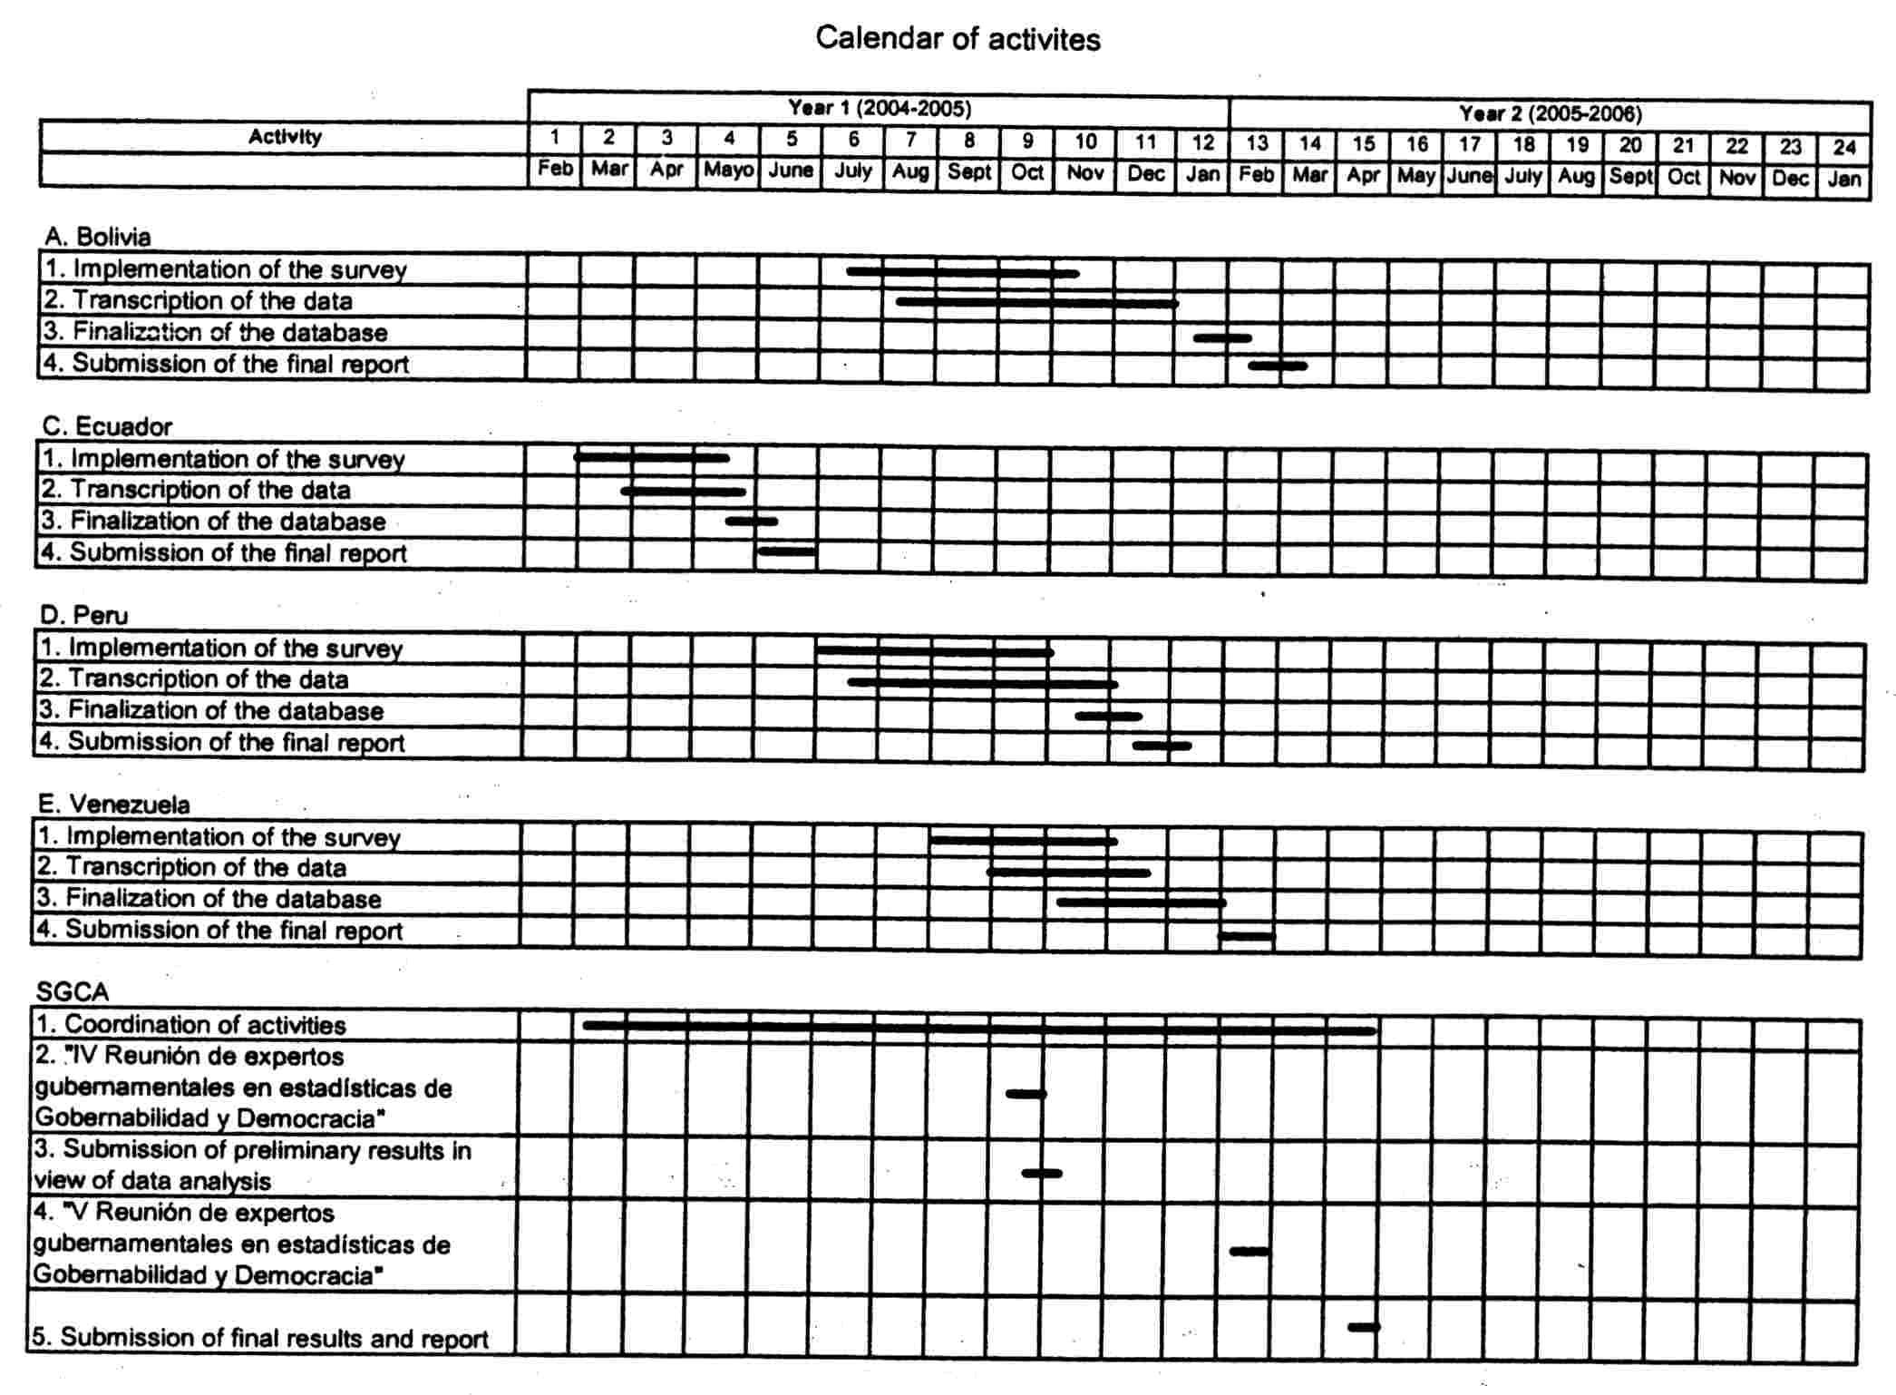

ANNEX II - BUDGET BREAKDOWN
7.1 Local costs of surveys and field operations

Expenses | Unit | Number of units | Cost per unit Euro | Cost (Euro)
7. Other costs, services
7.1 Local costs of surveys and field operations
Secretaría de la Comunidad Andina (Lima): Multi-country pilot activity B: Andean countries (field)
A. Plannig, coordination and logistics
A 1 ."General Secretary of the Andean Community
A.1.1 Salaries
A.1.1.1 Activity Coordinator | per month | 10 | 1500 | 15000
B. Support implementing National Statistical Institutes
B.1.1 Salaries
B.1.1.1 Specialists in quality  control (12 months each) | per month | 240 | 250 | 60000
B.1.2 Equipment
B.1.2.1 Computers |  | 20 | 1500 | 30000
B.1.2.2 Printer |  | 5 | 2000 | 10000
TOTAL |  |  |  | '  115000

Remark:
in accordance with article 14.2 of the present Agreement, the Partner organisation has the possibility to transfer funds between each single budget line up to a maximum of 15 % of the amount originally entered under this line without having to request a prior approval from the OECD.

ANNEX III – TERMS OF REFERENCE OF THE METAGORA PROJECT


EUROPEAN COMMISSION

European Initiative for Democracy and Human Rights

Targeted Projects

Budget Chapter B7=70

Terms of Reference of the Pilot Project

"Measuring Democracy, Human Rights and Governance"

(METAGORA )

Name of the organisation: | OECD / PARIS21
Date of approval: 27 December 2002
Dossier No | 2002/3052
(for internal use only)
0. EXECUTIVE SUMMARY
METAGORA is a 24 months pilot project based on innovative initiatives emerging from a North/South network. Its design is largely based on the operational conclusions of the international conference on Statistics, Development and Human Rights (Montreux, 4-8 September 2000), as well as on the results of subsequent consultations and workshops supported by the EC as a follow-up of that conference. METAGORA intends to bring statistical analysis into the hearth of monitoring DHRG and to promote proper matching of qualitative and quantitative approaches in view to enhance human rights reporting, governance evaluation and assessment of democracy. METAGORA aims in particular at:
- DEVELOPING METHODS AND PRODUCING PILOT TOOLS THAT WILL ALLOW TO OBTAIN DATA AND INDICATORS UPON WHICH BENEFICIARIES CAN FORMULATE OR EVALUATE POLICIES PROMOTING DEMOCRACY, HUMAN RIGHTS AND GOOD GOVERNANCE;
- IDENTIFYING AND ASSESSING CURRENT WORK AND INITIATIVES UNDERTAKEN IN THE NORTH AND THE SOUTH IN VIEW TO MEASURE PROGRESS IN THE FIELDS OF DHRG AND TO DEVELOP INDICATORS IN THESE FIELDS;
- PROVIDING GUIDELINESS ON METHODOLOGIES FOR MEASURING DHRG, TRAINING MATERIALS, DATABASES, AS WELL AS AN ON-LINE REPOSITORY OF PROJECT FINDINGS, RELEVANT MATERIALS AND EXPEMPLARY PRACTICES;
- PROPOSING CONCEPTUAL AND OPERATIONAL FRAMEWORKS FOR PROGRESSIVE ADOPTION AND USE OF INTERNATIONALLY AGREED GOVERNANCE INDICATORS.
METAGORA addresses needs for evidence-based policy-making, impact studies, aid delivery, empowerment of informed civil society and support to democratic dialogue, in particular in the context of distributive development. Beneficiaries will be national and local policy-makers, beneficiaries of public policies, civil society actors, international agencies and EC services. METAGORA is policy-oriented in scope, multidisciplinary in approach, inclusive and participatory in method. It gathers together the expertness of leading organisations and individuals of different continents who currently conduct policy-oriented research and field work in measuring DHRG. It will create outcome-oriented co-operation and synergies among the numerous actors and beneficiaries involved all along the project process at the local and the global levels.
The originality of METAGORA with regard to other existing international initiatives and projects in the field of DHRG assessment resides in its bottom-up approach to the development of internationally agreed indicators and related measurement methods. METAGORA intends to produce generic prototypes, guidelines and reference frameworks as global results of the implementation and evaluation of a few co-ordinated national and multi-country field operations and studies. Each of these co-ordinated pilot activities will focus on a specific theme and will primarily aim at assessing local policy implementation. These activities will consist on development and test of survey tools, innovative data collection, analysis and matching methods, targeted pilot indicators and dynamic databases. And such methods and tools will have a strong impact not only in terms of enhancement of national policy assessment and empowerment of local beneficiaries, but also in terms of acquisition of knowledge, experience and new methodologies which scope of application will extend far beyond the country specific local situation - as they could be further applied in other countries and cultural contexts. Experts and beneficiaries involved in the METAGORA working structures at the local and at the global levels will therefore ensure that results and lessons of the pilot activities be confronted, evaluated and translated in general lessons and guidelines. Thus METAGORA will be a domestically grown and owned project that, thanks to a co-ordihated process of cross-fertilisation, interaction and generalisation, will produce lessons of universal interest as well as concrete outcomes with big potential of replication and extension in the different regions of the world.
METAGORA will be conducted under the institutional aegis of Paris21/DECD. Its working structures include: i) a Project Co-ordination Team (5 persons) bound to the Paris21 Secretariat and therefore hosted within the premises of the OECD/DCD; ii) a Panel of Experts formed by some 14 outstanding statisticians and specialists in fields relevant for the project; iii) 7 Partner Implementing Organisations; iv) an Advisory Board gathering together representatives of some 30 national and international organisations involved or strongly interested in the project; and v) a Steering Committee of the Donors.
The budget of METAGORA, of a total amount of M€ 2.25, is financed by the EC, under the budget of the European Initiative on Democracy and Human Rights (67%), as well as by France (4%), Sweden (9%) and Switzerland (20%). The OECD shall be responsible for the management of these resources.

1. GENERAL FRAMEWORK
1.1 Subject
These Terms of Reference apply to the implementation of the pilot project "Measuring Democracy, Human Rights and Governance" (hereinafter referred as METAGORA). They are based on the proposal of a targeted project under the European Initiative for Democracy and Human Rights, submitted by OECD-Paris2l on 7 November 2002 (Dossier No. 2002/3052) and approved for funding by the EC on 27 December 2002.
The Terms of Reference take also into account the orientations emerging from the METAGORA Strategic Workshop that was hold in Paris on 23 and 24 May 2003, in which key stakeholders (including representatives of the EC, OECD-Paris21, the selected national organisations associated to the project, international governmental and non-governmental organisations) reviewed the design, scope, objectives, structures, methods of work and expected results of the project.
1.2 EIDHR Priority Theme addressed
METAGORA directly addresses EIDHR Priority Theme 1: Support to strengthen democratisation, good governance and the rule of law; but it will also have a cross-cutting impact on the other EIDHR thematic areas of action.
1.3 Responsible Organisation
The Organisation for Economic Co-operation and Development - Paris21 Secretariat (OECDParis21) will conduct the implementation of METAGORA in accordance with the present Terms of Reference. OECD-Paris2l will carry out METAGORA activities in partnership with selected institutions mentioned in these Terms of Reference and in collaboration with organisations and experts who will provide ad hoc intellectual services and technical assistance within the activities foreseen in the project. However EC recognises no contractual link between itself and the DECD-Paris21's partners or between itself and institutions or individuals involved in the implementation of METAGORA.
1.4 Duration
METAGORA will be implemented within a period of 24 months.
1.5 Budget
METAGORA total project costs amounts to M€ 2,25. The budget for the total duration of the pilot project (24 months) is annexed to the contract as Annex III.
1.6 Amount allocated by the European Commission
The amount allocated by the EC under the European Initiative for Democracy and Human Rights (Budget Chapter B7-70) is of € 1'510'000, that represents 67% of total project costs.
1.7 Amounts allocated by other donors
The following donors also allocated funds to finance the METAGORA project costs:
- France, Ministry of Foreign Affairs, Direction of Development and
Co-operation € 100'000 4 %
- Sweden, Swedish International Development Agency (SIDA) € 200'000 9
- Switzerland, Swiss Development and Co-operation Agency (SDC) € 400'000 18%
- Switzerland, Federal Department of Foreign Affairs, Political Division IV € 40'000 2
1.8 Working language
Meetings of METAGORA bodies, project reports and final products will be in English.

2. THE PROJECT
2.1 Focus
METAGORA focus on evidence-based monitoring of progress in the fields of democracy, human rights and governance (DHRG). It aims at developing tools and methods, matching qualitative and quantitative approaches, which will enhance human rights reporting, governance evaluation and assessment of democracy. It addresses urgent needs for evidence-based policy-making, impact studies, aid delivery, empowerment of informed civil society and support to democratic dialogue, in particular in the context of distributive development. Consisting in multidisciplinary and participatory work, outcome-oriented research, as well as co-ordinated field operations and pilot studies in selected countries, METAGORA will develop and test innovative DHRG measurement methods, approaches and frameworks, present context-based evaluation and provide guidance on the use of data, indicators, and statistical methods within policy-oriented reporting and decision-making.
2.2 Objectives
METAGORA shall pursue progressive emergence of broader applicability patterns in measuring DHRG. It shall promote dialogue on building these measurement tools and through its participatory approach contribute to build consensus between governmental authorities, experts and academic circles, NGOs and civil society on the evaluation of the policies at stake. It will in particular aim at:
- DEVELOPING METHODS AND PRODUCING PILOT TOOLS THAT WILL ALLOW TO OBTAIN DATA AND INDICATORS UPON WHICH BENEFICIARIES CAN FORMULATE OR EVALUATE POLICIES PROMOTING DEMOCRACY, HUMAN RIGHTS AND GOOD GOVERNANCE;
- IDENTIFYING AND ASSESSING CURRENT WORK AND INITIATIVES UNDERTAKEN IN THE NORTH AND THE SOUTH IN VIEW TO MEASURE PROGRESS IN THE FIELDS OF DHRG AND TO DEVELOP INDICATORS IN THESE FIELDS;
- PROVIDING GUIDELINESS ON METHODOLOGIES FOR MEASURING DHRG, TRAINING MATERIALS, AS WELL AS AN ON-LINE REPOSITORY OF PROJECT FINDINGS, KEY RELEVANT MATERIALS AND GOOD PRACTICES;
- PROPOSING CONCEPTUAL AND OPERATIONAL FRAMEWORKS FOR PROGRESSIVE ADOPTION AND USE OF INTERNATIONALLY AGREED GOVERNANCE INDICATORS.
2.3 Location of activities
A Project Co-ordination Team will be based in France (DECD-Paris21 premises in Paris). Targeted national pilot activities will take place in:
- Mexico (Mexico City)
- Philippines (Manila)
- Palestine (Ramallah)
- South Africa (Pretoria and field activity at country level)
- Sri Lanka (Colombo and field activity at country level)
Multi-country regional pilot activities will take place in:
- 8 African countries: Benin, Burkina-Faso, Ivory Cost, Madagascar, Mali, Niger, Senegal, Togo;
- 5 South American countries: Bolivia, Colombia, Ecuador, Peru, Venezuela (Andean Community);
NGOs, academic and governmental organisations in charge for co-ordinating multi-country regional pilot activities or providing cross-cutting technical assistance and intellectual services are based in:
- France (Paris)
- Sweden (Stockholm)
- USA (Washington and New York)
Moreover, experts and organisations from several EU Member states and third countries will be involved in short-term actions of technical assistance, in the activities of the Panel of Experts, as well as in the Advisory Board of the project (see 3.3 and 3.5).
2.4 Characteristics and scope of impact
METAGORA is policy-oriented in scope, multidisciplinary in approach, inclusive and participatory in method. It gathers together the expertness of leading organisations and individuals of different continents who currently conduct applied research and field work in measuring DHRG. Taking foot in such a powerful combination of scientific expertness in different fields, complementary professional skills and North/South cultural backgrounds, it shall:
- develop and promote multidisciplinary approaches and methods of work allowing progress in matching qualitative and quantitative analyses;
- stimulate outcome-oriented co-operation and synergies among the numerous actors and beneficiaries involved all along the project process at the local and the global levels;
- support local participatory processes of DHRG diagnosis and policy-oriented assessment;
- enhance target countries sustainable capacity for measuring DHRG issues;
- increase the accountability of the civil society and in particular of vulnerable groups through better capacity to use and interpret relevant information;
- contribute to ensure proper adequacy between choice of measurement tools indicators, and development goals/strategies;
- address the international needs for reference frameworks in the fields of DHRG indicators;
- contribute to improve monitoring and evaluation of DHRG programs of the EC;
- strengthen the EU network in the domains of governance, human rights and related issues, as well as the Montreux North/South network.
2.5 Beneficiaries
METAGORA addresses the needs for relevant information and reliable policy-oriented reporting of a broad variety of actors involved in the implementation, monitoring and protection of DHRG, in the North and in the South. These include national and local policy-makers, beneficiaries of public policies, civil society actors, etc. Institutions concerned range from research centres, NGOs, national human rights commissions, statistical offices, development agencies, EC services and international institutions.
Direct beneficiaries will be:
- local NGOs and civil society of target countries (empowerment, accountability)
- public institutions of target countries (transfer of know-how, institutional building)
- scientific community of target countries (associated to the project or benefiting from it for research)
- analysts of target countries (users of information)
- political actors of target countries (informed political debate and decision-making)
- political authorities of target countries (informed policy planning)
- EC services (evaluation of programs)
- National and international development agencies (idem)
- international NGOs (users of information)
Indirect beneficiaries will be:
- vulnerable groups in target countries (as beneficiaries of well informed policies)
- international scientific community (replication and extension of methods)
- international analysts (users of information)
- international media (users/producers of information)
2.6 Addressing differentiated needs of beneficiaries
METAGORA must address both, the specific needs and priorities of local beneficiaries involved in the project (definition of policies to be assessed and outcomes to be produced), as well as the needs and priorities of major global beneficiaries (needs for internationally agreed governance indicators, for agreed methodologies to be applied throughout EC programs, for training and reference materials).
METAGORA shall contribute to enhance beneficiaries' awareness of the state of the art in measuring DHRG, their knowledge of/ and access to existing expertness, and their capacity to use (and to avoid misuse) of data and indicators on governance. Close involvement of beneficiaries in the implementation of METAGORA at the local and at the global levels will constitute an essential precondition for ensuring a multiplier effect both as outcome and as a side effect of the project.
2.7 The bottom-up approach
The originality of METAGORA with regard to other existing international initiatives and projects in the field of DHRG assessment resides in its bottom-up approach to the development of internationally agreed indicators and related measurement methods. METAGORA intends to produce generic prototypes, guidelines and reference frameworks as global results of the implementation and evaluation of a few co-ordinated national and multi-country field operations and studies. Each of these coordinated pilot activities will focus on a specific theme and will primarily aim at assessing local policy implementation. These activities will consist on development and test of survey tools, innovative data collection, analysis and matching methods, targeted pilot indicators and dynamic databases. And such methods and tools will have a strong impact not only in terms of enhancement of national policy assessment and empowerment of local beneficiaries, but also in terms of acquisition of knowledge, experience and new methodologies which scope of application will extend far beyond the country specific-local situation - as they could be further applied in other countries and cultural contexts. Experts and beneficiaries involved in the METAGORA working structures at the local and at the global levels will therefore ensure that results and lessons of the pilot activities be confronted, evaluated and translated in general lessons and guidelines. Thus METAGORA will be a domestically grown and owned project that, thanks to a co-ordinated process of cross-fertilisation, interaction and generalisation, will produce lessons of universal interest as well as concrete outcomes with big potential of replication and extension in the different regions of the world.
2.8 A complement to global approaches
Today the urgent need for sensitive DHRG assessment and reporting tools can and should be addressed by different complementary approaches. Current global approaches to the development of indicators are mainly oriented towards international comparison and global overview; but they have limited potential application to comprehensive assessment of DHRG at national level and to effective monitoring and evaluation of national policies. The bottom-up approach of METAGORA emerges from the assumption that national statistical and analytical capacities are the more solid basis on which sustainable assessment tools can be built and used for relevant aims. Nevertheless METAGORA does not intend to be a competing alternative to the global, top-down approaches, but a useful complement to these, as it will provide global frameworks and composite indicators with lessons from statistical analysis, surveys-based studies and pilot DHRG assessment conducted in the field. METAGORA will build on lessons of past and current attempts to improve DHRG assessment at the global as well as at the national levels. It will in particular take lesson and benefit from the substantial conceptual work developed by the World Bank Institute (framework of measurable governance concepts and "worldwide aggregate governance research indicators dataset"), by International IDEA ("democracy assessment frameworks"), by the OECD Development Aid Committee (DAC) and its Network on Governance, GovNet (evaluation of programs promoting participatory development and good governance), by the work developed by Eurostat and by the Office of the UN-HCHR (in particular the map making and analysis of initiatives on developing indicators) as well as by SIDA and other development agencies (analysis of frameworks for evaluating DHRG programs).
2.9 Meeting the need for internationally agreed DHRG Indicators
Recent Human Development Reports focusing on human rights (2000) and democratic governance (2002) revealed a dramatic gap between, on the one side, the centrality of these themes for ensuring a global sustainable human, development and, on the other side, the endemic lack of reliable data and indicators of progress. Aso, in a report addressed to the UN Statistical Commission, the Human Development Report Office of the UNDID stresses that "human rights and governance (...) are difficult to quantify, largely because there is little agreement on the concepts and the standards, and because questions such as how many prisoners are tortured, how free are the news media, or how widespread is corruption are unlikely to be answerable in terms of official statistics. No international organisation has speciffc responsibility for governance. The World Bank has done a lot of work in recent years in trying to establish objective measures of governance. Other, mainly non-governmental, international organisations and researchers have also done conceptual work and published some measures in recent years. But the data vary in their time scales and their country overage and, when they provide quantitative scores, they are often based on qualitative data.".
Echoing the statement of the UNDID, an "assessment of the statistical indicators derived from United Nations summit meetings", established by the "Friends of the Chair of the UN Statistical Commission", notes that "for (...) policy areas such as human rights and good governance, no established indicators exist"- and that, in these areas, "the development ⁻of statistical indicators (...) will not be easy and will take time". The "Friends of the Chair" therefore recommended to the UN Statistical Commission that it "establish a mechanism (...) involving statisticians and ,others, including policy officials, to develop statistical indicators of human rights and governance". They stressed that "whatever is established needs to take account of existing initiatives in the field, in particular of follow-up activities to the international conference held in Montreux (..) in 2000." And they prudently state that "although we recognize the importance of this area, we take the view that it would be better to 'get it right' rather than 'get it quick', if widespread ownership of the indicators is to be established around the world".
As in 2002 the UN Statistical Commission adopted this recommendation of the "Friends of the Chair", in 2003 Switzerland addressed the 34th session of the Commission with a room document that elaborates on the objectives and planned action of METAGORA, as well as on the inclusive and participatory marks of its working structures, and proposes that the METAGORA Advisory Board, together with the Paris 21 Task Team on Tools and Methods, act as the foreseen mechanism, involving statisticians and policy officials, to develop indicators of governance and human rights.
2.10 A facilitator and catalyst of the process
METAGORA is a pilot project and, as such, its objectives and outcomes must be defined within a limited scope⁻ but also in view to an ambitious pioneering impact. METAGORA does not aim at developing an exhaustive set of indicators to be proposed for international agreement; nevertheless the project can and should contribute to give a boost to a process of international agreement on a number of key concepts and standards. It is obvious that a "system" of reliable governance indicators would constitute an utopian goal, as for being effective such a system should not only be based on strong, clear and coherent conceptual basis, but also in much more numerous, differentiated and reliable sets of data than those that are today available, namely at the national level. Nevertheless concrete work in view to the effective production and test of pilot indicators must not be postponed until a beaming but remote future when the conceptual cathedral would be achieved and current statistical vacuum would be refilled by generous flows of relevant data.
Work in progress at the international level - as the. "worldwide aggregate governance research indicators dataset" of the World Bank Institute - should be seriously examined and confronted with other patterns and approaches as well as with' work in progress at the national level in some countries. Even if the reliability of the data that sustains these developments may often be questionable in terms of statistical standards, the conceptual and analytical frameworks drown in these contexts, as well as the efforts paid to build and analyse chronological series constitute clear marks of a serious pioneering attempt to pave the way towards the production of more solid and reliable tools.
In this context METAGORA can play a role as facilitator and catalyst of a process of informal dialogue and substantive exchanges between experts involved in work in progress as well as between relevant international governmental and non-governmental organisations wishing to meet the need for international agreed indicators of governance. Such a process should be inclusive and aim at building consensus on a catalogue of issues and on a plan of action to be proposed to the relevant bodies of the international community. It should be oriented towards concrete reachable targets and schedules in view to a progressive but effective and firm adoption of international statistical standards and key indicators in the field of governance - and, in a much more ambitious perspective, perhaps also in the field of human rights.
Diagram 1 illustrates the role that METAGORA can play in giving a boost to the dynamics of this process as well as the substantial contribution it can provide on the basis of its own approach, pilot activities and selected monitoring themes.

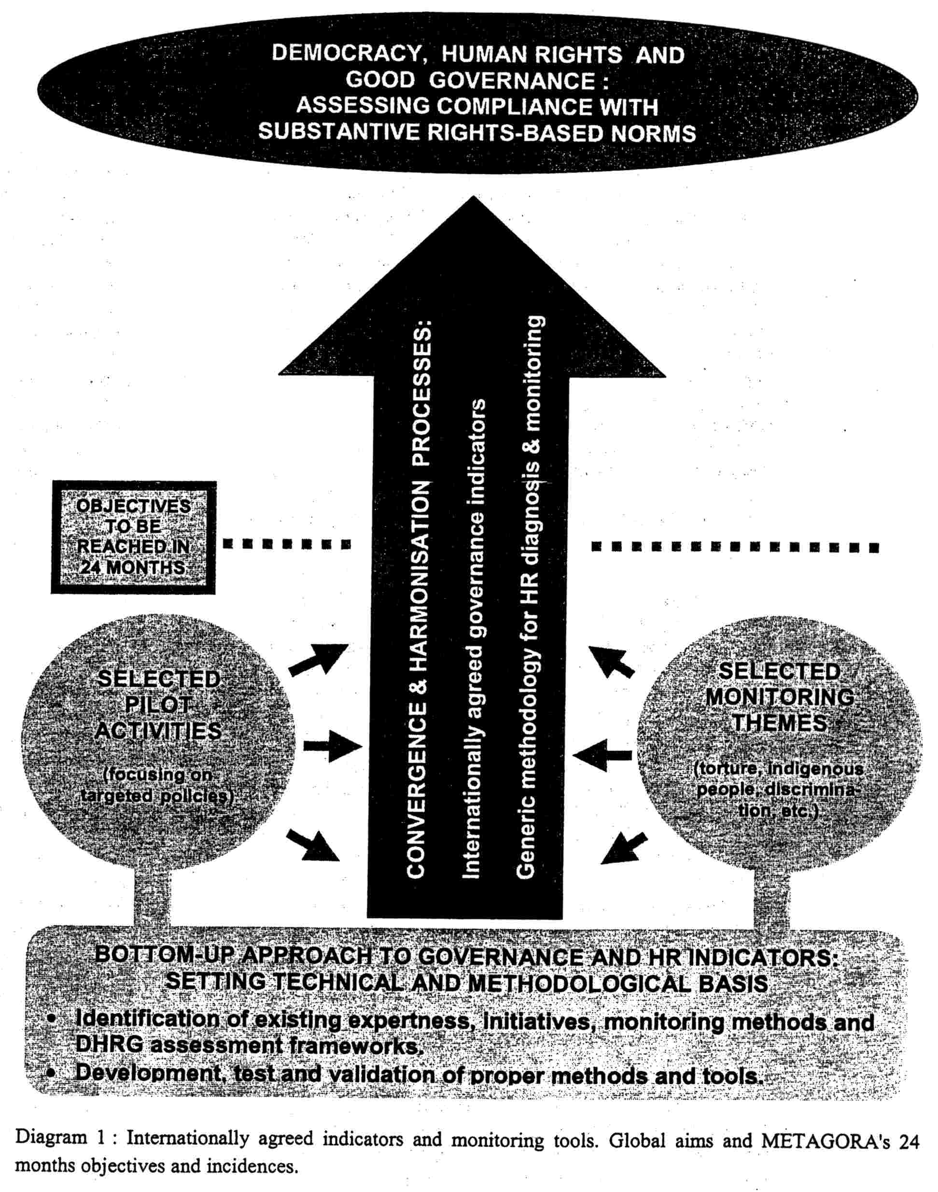

3. THE WORKING STRUCTURES
3.1 METAGORA Working structures will include:
a) a PROJECT CO-ORDINATION TEAM of 5 persons: a project general co-ordinator, a project officer, a junior professional officer, a budget officer (on 50% part-time basis) and an assistant.
b) a PANEL OF EXPERTS formed by :some 14 outstanding statisticians and specialists in fields relevant for the project.
c) SEVEN PARTNER IMPLEMENTING ORGANISATIONS (PIOs) that will be granted through the project budget for preparing and carrying out field operations and studies and/or coordinating regional actions and/or providing technical assistance and intellectual services:
- American Association for the Advancement of Science, ARAS, Washington;
- Développement et insertion internationale, CESD-Paris/DIAL, Paris;
- Fundar, Centro de Análisis e Investigación, Mexico City;
- Human Sciences Research Council, Pretoria;
- Palestinian Central Bureau of Statistics, PCBS, Albireh/Ramallah;
- Philippines National Commission for Human Rights, Manila;
- Secretaría de la Comunidad Andina, Lima.
d) EXPERTS who will be contracted through the project budget for providing intellectual services and technical assistance on ad hoc basis within the activities foreseen in the project;
e) an ADVISORY BOARD gathering together representatives of some 30 national and international organisations involved and/or strongly interested in the project;
f) a STEERING COMMITTEE OF DONORS gathering together representatives of the EC, France, Sweden and Switzerland, as well as DECD-DCD and the Paris21 Secretariat.
Diagram 2, at the end of this section, illustrates the position and relations of these working structures.
3.2 The Co-ordination Team
As METAGORA is largely based on a decentralised networking approach, and as the success of the project depends on the effective convergence of the various locally-based pilot activities into a common framework, a common schedule and common goals, it is essential that a small team of experienced professionals brings together all actions and elements of the project into a whole coherent common operation. The METAGORA Co-ordination Team must therefore ensure timely information flows, efficient organisation and strong co-ordinating leadership. It will therefore be in charge of the following functions: i) overall project management; ii) budget follow-up; iii) organisation of technical assistance, missions of experts and meetings of project bodies; iv) scientific co-ordination tasks and support to the Panel of Experts; v) follow-up of/ and support to PIOs and other project partners; vi) collaboration with GovNet and other relevant international networks and bodies; vii) analysis and synthesis of project results and reports; viii) advocacy for project's goals in local and international fora; ix) reporting to project's advisory and governing bodies; and x) development and management of METAGORA information tools, documentation and editing of project's documents. A matrix of the tasks and posts of the Co-ordination Team is attached to these Terms of Reference as Annex B.
3.3 The Panel of Experts
The Panel of Experts will play a central role as the effective engine of METAGORA. Its work will aim at: i) ensuring internal methodological and operational cohesion of the project as a whole; ii) fostering interactions between the various activities; iii) guiding and checking the adequacy of each activity with overall METAGORA objectives; iv) providing technical and scientific support to PlOs; v) controlling quality and reliability of methods and tools generated and used in each activity; vi) fostering multidisciplinary and participatory processes of collaboration between experts and actors involved in the implementation of all METAGORA activities; vii) ensuring effective restitution of know-how and efficient partnership and co-operation; viii) evaluating results of pilot field operations and studies, drawing global lessons based on them and assessing quality of the whole project; ix) ensuring and organising rigorous scientific peer-reviews of the project's results and products; and x) reviewing and endorsing the METAGORA Outline Guidelines, training materials and project's key reports.
The Panel will gather together internationally recognised outstanding experts from the South and from the North. It shall include experts from each PIO. Members of the Panel will conduct regular field missions, have intensive exchanges by means of electronic communication and the Panel as such will hold 6 technical meetings over the 24 months duration of the pilot project (4 plenary and 2 task forces).
3.4 The Partner Implementing Organisations (PIO)
PIOs listed above (see 3.1) will be involved and strongly committed at four levels of METAGORA:
a) they will be in charge, on the basis of detailed terms of reference, of the implementation or coordination of selected pilot field operations and studies financed through the project's budget. This will imply not only managerial, organisational and reporting tasks,' but also a substantive leadership in the co-ordination of local experts and the guidance of the operations towards the METAGORA goals and expected results. Moreover PIOs will take responsibility for setting participatory local teams and fora where all relevant actors and beneficiaries can provide advice and support to the development of the activity and can also be associated to the evaluation and policy-oriented analysis of results;
b) they will play a crucial role in the Panel of Experts, as they take responsibility not only for the implementation of the field operations at the local level but also for the whole METAGORA process towards the generation of methods, tools and frameworks of global relevance. In this context, PIOs will take -a pro-active part in frequent electronic exchanges, in the preparation and follow-up of the meetings and in the implementation of scientific and technical home work;
c) they will also play a key role in the development of interaction and synergies among the different pilot activities, conducting direct exchanges and carrying out targeted missions of technical assistance to other partners.
d) they will be part of the METAGORA Advisory Board (see 3.5) and, in this context, their role will be crucial in many regards: PIOs will be at the same time the voice of local beneficiaries, the witness of the difficulties and achievements of METAGORA in the field, and the more qualified technical and scientific observers and actors within the whole process, from the design of local data collection, to the interaction and cross-fertilisation of various activities, to the drawing of global lessons and guidelines.
The tasks to be carried out by PIOs at the different levels mentioned above obviously exceeds the capacity of one single expert; thus they will set up local teams gathering together different expertness and professional skills.
3.5 The Advisory Board
All current international players in the field of DHRG assessment as well as all global potential beneficiaries of METAGORA should have the possibility to be informed on the development and outcomes of the project and should also have the opportunity to formulate their speck needs and to provide advice on its implementation and results. The METAGORA Advisory Board will therefore gather together, on informal and voluntary basis; representatives: of major relevant actors and beneficiaries, including the EC and other donors, the PIOs associated to the project, as well as several national and international governmental and non-governmental organisations that are involved or strongly interested in the project. The Advisory Board will therefore. be.. a participatory and multidisciplinary body associating the varied range of competencies that are necessary for promoting, on informal basis, international policies aiming at enhancing proper DHRG measurement and assessment methodologies, for initiating and supporting processes of adoption of internationally agreed indicators, and for strengthening existing frameworks and fora for DHRG policy-oriented analysis. The Advisory Board will have an informal status but participants to the meetings should be high-level experts who will be able to present the policies and views of their organisations with full authoritative voice. The Advisory Body will have three meetings in 24 months. Travel costs related to the attendance to these meetings will be at the charge of the participants.'
The following international agencies have been invited to be part of this Advisory Board: EC instances concerned (EuropAid, DG Relex and Eurostat), the' Council of Europe, OECD, UNDP-HDR Office, OHCHR, the World Bank and the World Bank Institute, ILO, UNICEF, UNSTAT, the UN Economic Commissions for Africa, Europe, Latin-America and the Caribbean, International-IDEA, Afristat and the Andean Community Secretariat.
In the course of the different phases of the design and preparation of METAGORA the following international NGOs expressed interest in the objectives and planned action of the project and will therefore be invited to attend the meeting of the Board: the International Council on Human Rights Policy; Social Watch; the Economic Research Forum for the Arabic Countries, Iran and Turkey; HURIDOCS - Human Rights Information and Documentation Systems; and Rights & Democracy - International Centre for Human Rights and Democratic Development.
The following national organisations expressed their wish to be represented within. the Board:
a) Institutions from EU member States:
- Denmark: Danish Centre for Human Rights
- France: Ministry of Foreign Affairs, Direction for Co-operation and Development
- France: GIP-ADETEF, Ministry of Economy, Finance and Industry
- France: CESD-Paris / DIAL - Développement et insertion internationale
- Germany: GTZ
- Netherlands: Netherlands Institute for Human Rights (SIM)
- Spain: Instituto Internacional de Gobernabilidad, Cataluña
- Sweden: Swedish Co-operation / SIDA
- Sweden: Statistics Sweden
b) Institutions from third countries:
- Albania: National Statistical Institute
- Argentina: Instituto Nacional de Estadística y censos
- Israel: Central Bureau of Statistics
- Jordan: Department of Statistics
- Kyrghyz Republic: National Statistical Committee
- Mexico: FUNDAR, Centro de Análisis e Investigación
- Norway: Statistics Norway
- Palestine: Palestinian Central Bureau of Statistics - PCBS
- Palestine: Birzeit University
- Philippines: National Commission on Human Rights
- Philippines: ESCR-Asia
- South Africa: Human Sciences Research Council - HSRC
- Switzerland: Swiss Development and Co-operation Agency
- Switzerland: Federal Department of Foreign Affairs, Political Division IV
- Switzerland: University of Fribourg, Institut interdisciplinaire d'éthique et des droits de I'homme
- USA: American Association for the Advancement of Science, Science and Human Rights Program
- USA: Columbia University
3.6 The Steering Committee of Donors
The Steering Committee of Donors will be formed by representatives of EC and of the donor institutions of France, Sweden and Switzerland, as well as of DECD-DCD and the Paris21 Secretariat. The Committee will closely follow the advancement and results of the project, providing support and guidance to the Co-ordination Team. It will examine the intermediary and final activity and financial reports, as well as all documents produced by the project that would be of relevance for the donors. In case of non performance of duties by the METAGORA Co-ordination Team or by a Partner Implementing Organisation, or in case of unexpected need for substantial changes in planned activities, the Committee will discuss and decide on concrete steps to be taken or on important changes to be introduced in the working plan and structures of the project. The Committee will have three meetings in the course of the 24 months period of execution of the project.
3.7 Integration of METAGORA within the OECD/Paris21 structures
METAGORA will be conducted under the institutional aegis of Paris21 (PARtnership In Statistics for development in the 21st Century) that is itself a unique North/South consortium which membership, profile and structures encompasses the governmental and non governmental organizations, national statistical institutes, research institutions and international agencies that are playing, or intend to play, a significant role in assessing governance and human rights.
The development and results of METAGORA will be followed by the Paris2l Task Team on Tools and Methods, which mission includes the review of indicators, tools and methods aiming at assessing progress of development processes, including poverty alleviation, quality of governance, accountability and participation.
The METAGORA Co-ordination Team will be bound to the Paris21 Secretariat, under the supervision of the Paris21 Manager, and hosted within the premises of the DECD/DCD. The METAGORA general coordinator will report to the Paris21 Task Team on Tools and Methods and to the Paris21 Steering Committee.
The Paris21 Steering Committee is currently chaired by Mr. Pali Jubo Lehohla (South Africa) and its membership includes: EC, IMF, OECD, UNDP, UNFPA, UNSD, World Bank, and countries representing: Anglophone and Francophone Africa, Arab States, Asia & Pacific, Central & South America, CIS countries, EU Member States, Switzerland and USA.
3.8 Links and synergies with OECD-DAC and GovNet
METAGORA shall link and ensure synergies and interaction with ongoing work on governance indicators carried out within the OECD Development Aid Committee (DAC) and its Network on Governance (GovNet). The METAGORA Co-ordination Team shall collaborate in a.day-to-day basis with the secretariats of DAC and GovNet, and membership of the METAGORA Advisory Board will include selected members of both instances.
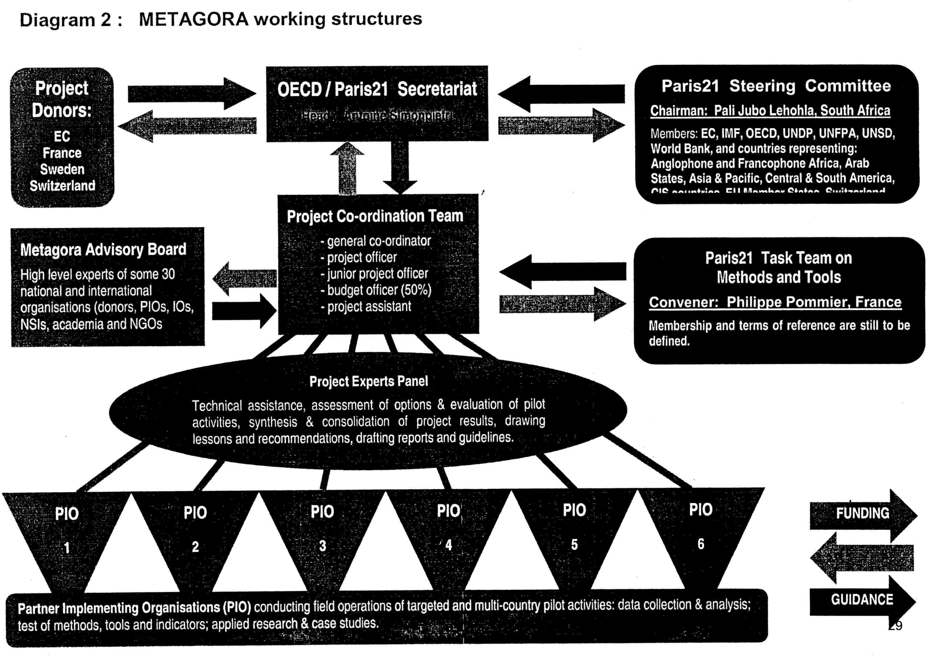
4. THE PILOT ACTIVITIES
4.1 Characteristics
METAGORA pilot activities shall be inclusive, participatory and outcome-oriented. They shall address major policy issues with scientific and technical rigor. They shall be co-ordinated among them within the framework of the working structures and general schedule of the project - and they shall pursue the global aims and expected results of the project as a whole. They shall in particular:
- focus both on major relevant national policy issues and on selected EU priority themes (such as torture, indigenous people, discrimination, etc.);
- have a big potential of replication and extension in other national and cultural contexts;
- involve local beneficiaries and all relevant players in the preparation and implementation of field actions as well as in the analysis of results;
- be implemented as parts of a decentralised laboratory, complementing each other and developing synergies and interaction among them;
- be duly documented and subject to mutual peer-review and evaluation within the Panel of Experts;
- produce tangible results and policy-oriented reporting within the deadlines of the project.
4.2 Areas of activity
METAGORA pilot activities shall focus on FOUR AREAS:
A) IDENTIFICATION AND ANALYTICAL ASSESSMENT OF CURRENT WORK AND INITIATIVES AIMING AT MEASURING PROGRESS IN THE FIELDS OF DHRG:
- Activity 1: cross-cutting activity conducted by senior ad hoc experts and the Panel of Experts.
B) DEVELOPMENT OF PILOT SURVEY-BASED ASSESSMENT METHODS:
- Activities 2 and 3: Survey-based HR diagnosis and monitoring (Mexico and Philippines)
- Activity 4: Monitoring democracy and governance through households surveys (13 countries) - Activity 5: Survey-based auditing of D and HR in the context of land reform (South Africa).
C) STATISTICALLY-BASED RECORDS AND DATABASES: DEVELOPMENT OF THE TOOLS AND TRAINING OF USERS / BENEFICIARIES:
- Activity 6: Quantitative analysis and records on HR violations; training beneficiaries (Sri Lanka) - Activity 7: Dynamic database on D and HR, pilot indicators of progress and training (Palestine) - Supporting research and development of a model for multiple system estimation of totals (USA)
D) GOVERNANCE INDICATORS: CONCEPTUAL FRAMEWORK AND OPERATIONAL PLATFORM FOR ADOPTION OF INTERNATIONALLY AGREED INDICATORS:
- Cross-cutting activity conducted by an ad hoc task force of the Panel of Experts with the support of the Co-ordination Team and in link with the Advisory Board and the Paris21 Task Team for Tools and Methods.
4.3 Co-ordination, interaction and convergence into a global outcome
As described before (3.2 and 3.3), the METAGORA Co-ordination Team will be in charge of the operational co-ordination of the pilot activities within the schedule and organisational frameworks of the project, while the Panel of Experts (that includes representatives of all PIOs in charge of the pilot activities) will ensure substantive co-ordination and interaction of the pilot activities as well as the convergence of their outcomes in the global objectives and expected results of the project as a whole.
4.4 Implementation phases
In the course of 24 months the pilot activities will develop through the following stages of local implementation, cross fertilisation and local/global interaction:
a) Local: Preparation of field operations: building local teams with experts and beneficiaries, participatory design of surveys and questionnaires design, training interviewers, etc.
b) Local: Data collection, processing and matching, data quality analysis.
[ FIRST CROSS-FERTILISATION
c) Local/Global: analysing results, matching quantitative & qualitative data, testing pilot indicators.
[ SECOND CROSS-FERTILISATION ]
d) Local/Global: National policy-oriented reports, evaluation of tools and methods.
[ THIRD CROSS-FERTILISATION ]
e) Global: production of global outcomes: outline guidelines, training materials, technical and policy-oriented reports.
Diagram 3, at the end of this section, shows how these phases are scheduled and co-ordinated, and how they relate to the schedules of the Expert Panel and the Advisory Board, in order to ensure a coherent development of the of whole project and effective convergence of all pilot activities in the overall objectives and outcomes of METAGORA.
4.5 Description of the activities

- IDENTIFICATION AND ANALYTICAL ASSESSMENT OF INITIATIVES AIMING AT MEASURING PROGRESS IN THE FIELDS OF DHRG

Activity 1, conducted by experts
A senior ad hoc expert, in collaboration with the Panel of Experts and with selected experts from different regions of the world, will conduct a specific activity aiming at producing a reference instrument on the state of the art in the field of DHRG monitoring methods, and to provide information and guidance on relevant existing expertness around the world. As a concrete outcome, this activity will produce an analytical inventory of national and international initiatives undertaken in view to enhance proper assessment and monitoring methods in the fields of DHRG. Moreover, a selected universal bibliography on DHRG indicators and related measurement methods will be established in collaboration with experts of different languages and cultural environments. The METAGORA co-ordination team will pursue all efforts to ensure synergies and interactions with ongoing work in this area carried out by Eurostat and the Office of the UN High Commissioner for Human Rights.
On the basis of a database developed within the framework of the preparation and follow-up of the international Conference on "Statistics, Development and Human Rights", a targeted survey of relevant national institutions and experts shall be carried out in view to collect basic information on the objectives, sources and methods of recent and current work, as well as on the related literature. This shall provide for the first time an extensive overview of the effective attempts to measure DHRG in the field. And this shall in particular include current work and recent initiatives undertaken by public bodies, NGOs and research centres of the Southern hemisphere which are most often unknown or neglected by the studies on DHRG indicators carried out by Northern scholars and international institutions. Special attention will be paid to initiatives addressing vulnerable groups, such as women, children, pandemic victims, etc. At a second stage, an in-depth comparative analytical assessment of conceptual and operational relevance of initiatives will be conducted, based on an analytical grid to be designed in consultation within the METAGORA Panel of Experts.
A questionnaire targeting international organisations and bodies will be designed in informal but close collaboration with the Office of the High Commissioner for Human Rights that is currently identifying and mapping the initiatives undertaken by the UN Treaty Bodies in view to strengthen monitoring methods in the field of economic, social and cultural rights. As in big international organisations initiatives of a given department are often unknown by other departments, the questionnaire shall be addressed to all relevant departments and units of each organisation.
A draft anal report will be submitted for review to the Panel of Experts as well as to a broad circle of beneficiaries. It will in particular emphasize the relations and gaps between national (local) specific measurement objectives and international measurement framework.
The analytical inventory, as well as the final report and all other relevant materials produced in the framework of this activity will be made public in the form of an on-line repository that will be designed by professionals as a user-friendly research tool.

- DEVELOPMENT OF PILOT SURVEY-BASED ASSESSMENT METHODS

Activities 2 and 3 : Survey-based national human rights diagnosis and monitoring
Location of activities: Mexico and Philippines
PlOs: - Fundar, Centro de Análisis e Investigación (Mexico City, Mexico)
- Philippine National Commission on Human Rights (Manila, Philippines)
These pilot activities address the lack of reliable information basis that characterises current human rights monitoring mechanisms, which are mainly based on reporting of individual cases (or series of cases) to NGOs and to human rights commissions, as well as on judicial decisions. This form of monitoring is certainly invaluable for, purposes of advocacy on individual cases but it can not provide relevant and reliable information on the real dimension and trends of major human rights issues considered as collective, social and political phenomena.
Mexican and Philippine experts - statisticians as well as human rights practitioners - shall collaborate to design, develop and test innovative sampling survey approaches in view to collect and analyse relevant data - and on this basis to properly estimate the dimension, trends and mechanisms of key human rights issues. In both countries the pilot activities aim at providing reliable information to the civil society and to the public authorities on how respect for human rights evolves, which are the vulnerable groups, how are they abused, and in which direction corrective plans and measures can usefully be introduced. Thus the obvious universal interest of these pilot activities consists in their promising potential to propose generic methods and tools for proper monitoring of human rights issues and for evidence-based assessment of related targeted policies.
The pilot activity in Mexico will be implemented within the framework and as a follow-up of a major national human rights diagnosis that is currently being conducted in collaboration with the UN High Commissioner for Human Rights. The activity specifically intends to enhance monitoring tools in the field of ILL-TREATMENT AND TORTURE. It will consist in: i) participatory consultation and multidisciplinary work on the design and implementation of a double-sample pilot survey; ii) testing a method for sensitive data collection in a selected geographical area; iii) analysing and interpreting the data collected; iv) matching quantitative results and qualitative analysis; v) identifying convergence and gaps between the results of the pilot survey and the information provided by other existing monitoring tools; vi) drafting and publishing a policy-oriented report; vii) drawing up technical conclusions and recommendations.
The pilot activity in the Philippines will focus on the human rights of INDIGENOUS PEOPLE. The activity will be conducted by the Philippines National Commission on Human Rights, in close cooperation with the National Statistical Co-ordination Board of the Philippines, and in collaboration with a national network of governmental, non-governmental and academic organisations. Building on lessons from the design and implementation of the pilot survey conducted in Mexico, the activity will consist on conceptual and preparatory work to conduct a survey on human rights that fits with the specific context prevailing in the Philippines and with the specific indigenous people issues and related public policies. The activity will therefore consist in preliminary conceptual and methodological work, the establishment of institutional and operational frameworks in view to the implementation of the survey, and the development and pre-test of questionnaires and appropriate methods for data collection.
Activity 4 (Multi-country): Using household surveys as a tool for monitoring poverty, governance and democracy in Africa and the Andean region
Location of activities: In Africa: 7 capital cities of Western African countries (Benin, Burkina-Faso, Côte d'Ivoire, Mali, Niger, Senegal, Togo), 7 cities of Madagascar. In Latin America: 5 countries of the Andean Community (Bolivia, Columbia, Ecuador, Peru and Venezuela
PlOs: - CESD Paris/Dial - Développement et insertion internationale (Paris, France)
- Secretaría de la Comunidad Andina (Lima, Peru)
The objective of this pilot activity is to refine measurement tools and to test the capacity of statistical household surveys based on the 1-2-3 technique to provide relevant information on key aspects of democracy and governance. The activity will consist in the implementation of representative sample surveys on households' experiences, perceptions and expectations on governance and democracy in a number of countries in Africa and the Andean region. It will therefore consist in collection and analysis of information on the living conditions of the population as well as of objective and subjective data on governance and democratic participation. This should allow to evaluate to what extent the views and expectations of the population are taken into account by governments' policies. In this sense, the survey approach appears as a participatory channel of information, as in many countries household surveys offers a unique opportunity to the population, especially to the poor, to express their opinion, providing them with a "voice" and making them heard in the decision-making process.
As the data is collected within the framework of large sample surveys, it will be possible to disaggregate the results according to different categories of population and to obtain information that is sensitive to the rights of specific groups (e.g. corruption incidence, political participation, access to basic needs are not supposed to be uniform among social groups) and to assess their specific situation in terms of needs and progress. The first analyses will describe and compare the situation between the different countries studied, and will also allow identifying the most relevant indicators and their potential and limits for enhancing the assessment of governance and democracy. The activity is intended to allow analysis of the evolution of the indicators over the time (by repeating the surveys in the same countries).
As the final objective of the pilot activity is to explore the links between democracy, the way its works in practice, the value system of the society and people's living conditions, the analyses will focus on three main interconnected topics
- Poverty and its multiple dimensions: subjective perception by households of their well-being, their degree of vulnerability, their degree of insertion/integration or exclusion from society; their degree of participation or marginalisation, insecurity, their level of information;
- Perception of governance: the level of confidence of people in their institutions; corruption, management of administration and public services in general; households' assessment on policies implemented; the role of State and its credibility;
- Assessment of democracy: people's judgement on the way democracy works (or does not work), on the adequacy of the regime to the national context, on values considered as essential in a particular society, as well as on the realisation of their rights in this context.
This pilot activity will be implemented by DIAL in close collaboration with South American and African expert teams (Andean Community General Secretariat and statistical offices of the region; Afristat and statistical offices of the region). The Secretariat of the Andean Community will be in charge for the operational co-ordination of field work in South America while DIAL will be responsible for substantive co-ordination and for bringing technical assistance to the national teams to prepare and launch the surveys, as well as for the processing and analysis of the data. This will include training at the national level and regional seminars (specific for African and Andean countries) aiming at reviewing the implementation of the activity, as well as at analyzing the results and preparing their presentation to the public and their integration within the global METAGORA objectives.
Activity 5 : Auditing the realisation of democracy and human rights in the context of land reform
Location of activities: South Africa
PlOs: - Human Sciences Research Council (Pretoria, South Africa)
The general objective of this pilot activity is to design, test, evaluate and refine a methodology for measuring the realisation of democracy and human rights in the context of South Africa's current land reform programme. This programme is proceeding in the absence of hard and detailed information as to the demand for land amongst the disadvantaged for whom it is meant. The activity intends to encompass both objective measures of performance of land reform, but as importantly measures of perceptions, attitudes and expectations, that are critical to understanding land reform as a governance and human rights issue.
Indicators will be developed for response at individual and household level, and that will touch on five main dimensions: i) circumstances and situation (e.g. employment status, tenure status, etc.), ii) experiences with land in general and land reform in particular, iii) knowledge/understanding of land reform and land administration issues, iv) attitudes towards land reform and land administration, v) needs and expectations in respect of land reform. The survey instruments will be designed in such a way that these five dimensions will be brought to bear on the specific thrust of South Africa's land reform, but also in a more general fashion so as to be more broadly applicable, e.g. to other DHRG relevant policies and to other countries. A.policy-oriented substantive report and a methodology report will be produced, and data produced will be made freely available to the public. The activity will be conducted by the Human Sciences Research Council of South-Africa (HSRC), in close co-operation with Statistics South-Africa.
Beyond the analysis of the various factors and EC themes involved in this pilot activity, such as the RACIAL DISCRIMINATION that is at the historical background of current land ownership in the country, one of the major contributions of this pilot study to the global METAGORA objectives resides in its focus on "auditing" a key national program - and therefore in its promising potential to generate global recommendations for enhancing evidence-based DHRG policy assessment.

- STATISTICALLY-BASED RECORDS AND DATABASES:
DEVELOPMENT OF TOOLS AND TRAINING OF USERS /BENEFICIARIES

Activity 6: Quantitative analysis and records of human rights violations in Sri Lanka
Location of activities: Sri Lanka
P/O: American Association for the Advancement of Science - AAAS, Science and Human Rights Program (Washington, USA)
This pilot activity, of major relevance for global METAGORA objectives, focus on the particular situation of Sri Lanka where, within the ongoing peace process, political and civil society actors are debating about the patterns, magnitude, and responsibility for violations in the past as well as about allegations of ongoing violations. In this context, establishing a scientifically-rigorous record of reported and estimated total numbers of violations will help to clarify the past and to build a common memory of the responsibility for violations by both the State and insurgent forces. It is also perfect timing for strengthening the country capacity for generating a regular system that allows maintaining a record of current abuses, thus providing the basis of information needed to assist monitoring bodies to shape policy and assess impact on peace process and democratization. This activity will build tools for both objectives.
The activity specifically aims at empowering the organised civil society. It shall continue a two-year effort of the Human Rights Documentation Coalition (HRDC), a broad consortium of NGOs based in Sri Lanka, to establish definitions, classification manuals, and conduct training directed towards the establishment of a common technical basis for quantifying the patterns and magnitude of gross human rights violations. The work, supported and supervised by AAAS in collaboration with an ad hoc expert, will be undertaken as a collective effort by the national coalition members. It will be carried out through the following phases: i) the organisation of ongoing activities of the coding group, ii) local low intensity coding, iii) assessment of progress and technical supervision, iv) continuation of low intensity coding, v) high-intensity coding with field supervisor in residence, vi) preliminary analysis and report at the end of Year 1, and vii) policy-oriented conclusions and lessons from Year 1.
On the methodological level, the work will assess the possibility of using multiple, independent enumeration of a phenomenon (like those of the various Sri Lanka coalition projects), so that estimates can be made of the total extent of the phenomenon, including those cases which were never enumerated. The ability to link multiple reports also permits organisations to monitor inter-rater reliability (IRR), the measure of how reliably different members of the coding team code the same reports. Altogether, implementing this technique has a clear impact on. the quality of output, and reinforces capacity building potential of the activity.
The first and most apparent result of this activity will be the enhancement of the capacity of beneficiaries (Sri Lanka NGOs) to monitor human rights using statistical techniques and therefore the enhancement of their voice, based on more rigorous and more convincing arguments, within the peace process. At a more global level, and in the perspective of the METAGORA objectives, the range of experiences that will be tackled in the process of implementing this activity (development of methods for measuring human rights violations, technical capacity building of local actors, increased sensitivity to the value of policy-oriented information basis, empowering national dialogue) constitute key potential sources of universal lessons both at the level of the process and at the level of the scientific and technical methods applied.
Activity 7 : Dynamic database on democracy and human rights and pilot indicators in Palestine
Location of activities: Palestine
PIO: Palestinian Central Bureau of Statistics (El-Bireh)
The main objective of this pilot activity is to reinforce capacity for large scale monitoring of participatory democracy and human rights in Palestine. The activity aims at integrating within a single framework existing information on 'a range of key issues relating to participatory democracy and human rights, in particular civil and political rights. On the basis of qualitative and quantitative criteria, the information collected from various sources shall allow to construct sustainable indicators of progress. A limited set of indicators shall be designed and tested. This activity includes a strong component of training of beneficiaries in order than they can play a double role as providers and users of relevant information.
Today in Palestine official and non- official surveys on the living conditions of the population produce important information that can and should be analyzed for purposes of monitoring rights and democratic processes. Moreover, various academic institutions, official bodies and non- governmental organization collect various kinds of data that may be relevant in terms of information on current trends of human rights implementation. This pilot activity therefore intends to identify the most accurate available sources of information (including surveys and non-official information such as that recorded by NGOs on a case-by-case basis) and to develop a tool for integrating into a coherent and structured stock of information the sets of data provided by those sources. The final product of this work shall be a dynamic database for systematic recording and matching of data over time. This database should provide a common basis for gathering, coding and analyzing sets of information of different sources that otherwise may remain fragmentary, anecdotal and irrelevant for large scale analysis. Such a database shall not only provide up- to date data on democracy and human rights, but also enable the derivation of time series and indicators that can be sustainable over time. It shall be made available to the public, including the research community, to domestic policy makers -and planners, to NGOs as well as to the international community.
Beneficiaries shall be involved all along the process of implementation of the activity, providing advice on the design of the database as well as receiving training on how to improve the skills for coding information, building databases, identifying and interpreting quantitative and qualitative data, using (and avoiding misuse) of indicators, and improving the skills for reporting.
Both the expected local impact of this pilot activity and its potential global lessons in view to the METAGORA objectives are crucial, as the process of the activity itself and its tangible outcome should:
- reinforce professionalism, accuracy and objectivity in human rights reporting;
- encourage evidence-based research on democracy and human rights in Palestine;
- allow the production of policy-oriented reports on a continuous basis, with possible comparisons over time;
- enhance national participatory fora and promote interdisciplinary monitoring work involving official statisticians, experts from the academia and human rights practitioners;
- contribute to a clearer analysis of democracy and human rights in Palestine as well as to a more transparent and democratic dialogue.
The activity will be conducted by PCBS in collaboration with research institutions and NGOs, and in particular with experts from ⁻Birzeit University involved in the democracy index initiative for Palestine. It shall benefit from the experience developed in other METAGORA pilot activities (in particular in Sri Lanka) and from the technical assistance of ad hoc leading experts in the fields of coding, processing, validating and matching data originally collected for non-statistical purposes.
Development of a model for multiple system estimation of totals
Supporting applied research conducted in: USA (New York, Columbia University)
The previously described pilot activities focusing on the development of statistically-based records and databases shall be accompanied and supported by a research activity, conducted by a senior outstanding statistician, aiming at refining methods for improving precision of estimates and counts of events to be recorded and reported.
Based on innovative. quantitative research and modelling, this work will develop theoretical and analytical basis for a model to estimate the number of events or persons that are not countable by conventional random survey methods. By means of computer simulations, the research will determine the precision of estimates and study the effects of biases and correlations, and give field investigators a guide for fieldwork on a current basis.
This activity is highly relevant with regard to the METAGORA objectives, as the potential scope of use of the prospected model in civil, political, social, and economic rights is broad, encompassing the estimation of numbers of human rights violations, victims, and persons not enjoying rights such as access to health care, polling violations. The results will enable the beneficiaries to make scientifically-informed estimates of counts of persons, events, and violations with a known precision.

D) GOVERNANCE INDICATORS:
CONCEPTUAL AND OPERATIONAL PLATFORM FOR ADOPTION OF INTERNATIONALLY AGREED INDICATORS
Cross-cutting activity conducted by an ad hoc task force of the Panel of Experts with the support of the Co-ordination Team and in link with the Advisory Board and the Paris2l Task Team for Tools and Methods.
This activity, of a cross-cutting nature, shall be a key strategic element of the whole METAGORA implementing process. Resting on the multidisciplinary North/South critical mass of expertness that will be gathered together within the various working structures of the project, it aims at facilitating an informal but structured process of dialogue between outstanding experts and relevant institutions wishing to contribute to an effective advancement of international agreement on a number of key concepts and standards in the field of governance assessment.
The activity shall be conducted by a small task team of the Panel of Experts, supported by the Co-ordination Team. It will be implemented at two levels:
- a level of informal policy dialogue within the METAGORA Advisory Board, involving all interested parties (producers of basic data and indicators, analysts, policy makers and practitioners) and
- a level of informal technical review, consultations and formulation of proposals, within the Paris21 Task Team on Tools and Methods, involving all relevant organisations that produce indicators as well as senior experts who are conducting work in progress.
The activity shall be outcome-oriented and build on good and bad lessons from the numerous open-ended meetings, brainstorming workshops and academic gatherings that focused on governance assessment in the course of the last years. It shall focus on reachable concrete targets rather than in encyclopaedic descriptions of "theories", "models" or "systems". It should meet specific urgent needs for a few key internationally agreed indicators of governance that could enhance proper evaluation of major national policies and EC programs.
Taking benefit from the findings of the parallel METAGORA activity aiming at identifying and assessing initiatives in the field of monitoring DHRG, this activity shell in particular:
- facilitate constructive assessment of work in progress in the international agencies as well as in relevant national organisations and research centres;
- allow to identify key concepts, frameworks, methods and standards that would be best candidates for policy and technical review and subsequent formulation of agreed recommendations;
- draw a map of the institutional frameworks and channels that would be concerned by a process of agreement on key governance indicators.
- produce a catalogue of issues that could be addressed by the relevant bodies on the international community with reasonable chances of agreement in the short and medium terms;
- formulate a proposal for a plan of action, including clear concrete targets and a general time-schedule, to be proposed to the UN Statistical Commission in view to subsequent transmission, for endorsement and support, to the relevant international instances, such as the UN Economic and Social Council.
The outcomes of this activity will be presented in the form of a substantive report containing two distinct parts: a proposal to be submitted to the UN Statistical Commission and an analytical repository of issues, open questions and incipient proposals that would need to be further considered before being submitted to debate in the international instances.
4.6 Working plan
A general working plan is outlined in diagram 3.
4.7 Co-ordination of pilot activities
As mentioned before (4.3 and 4.4), the pilot activities shall be coordinated both at the substantive and operational levels in view to ensure a coherent development of the whole project, as well as effective. convergence of all pilot activities in the overall objectives and outcomes of METAGORA. The coordinating roles and tasks of the Panel of Experts and the Co-ordination Team are described in 3.2 and 3.3.
4.8 Draft and review of final outcomes
The Panel of Experts will be in charge for drawing global lessons from the results of pilot activities and, under the direction of a senior outstanding expert, it will review the content and the form of the final products of METAGORA: the Outline Guidelines, the analytical inventory of initiatives, the training materials and the recommendations on internationally agreed indicators of governance. (see 5.3)
4.9 Closing Workshop
A closing workshop will be organized at the end of the 24 months period of the project. It will aim at: i) presenting the final outcomes and products of METAGORA; ii) analyzing the results of the pilot activities and their global lessons; iii) discussing with key stakeholders⁻ and policy-makers the potential application of methods and tools developed and tested within the project; iv) examining the perspectives for a systematic integration of these methods and tools within existing monitoring mechanisms as well as within regular evaluations of impact of EC policies and programs; v) considering how to build on initial achievements of the pilot project so that progress in DHRG measurement can further be achieved; and vi) proposing orientations for further concrete action.
4.10 Internal and external evaluations
The processes and outcomes of the pilot activities, as well as the production of global outcomes and final products of METAGORA will be subject to internal evaluations conducted by the Panel of Experts. These will include assessment of: i) the quality of results of pilot activities; ii) the methods and tools developed within the project; iii) the technical assistance provided to the PIOs; iv) the coherence, continuity, strengths and weaknesses of the METAGORA specific bottom-up approach and the participatory process all along the implementation of the whole project; v); the interaction between the various pilot activities; vi) the quality of the partnership among the various actors involved in the project; vii) the materialization of effective South-South co-operation.
The internal evaluation shall also include a general assessment of the whole process, and of the relevance of its results, to be conducted at the end of the project within the Advisory Board and by the ParIs21 Task Team on Tools and Methods.
Moreover, methods and tools developed by the project, as well as the main relevant results will be submitted to the scientific community, following well established practices of peer-review and publication. This is essential not only for guaranteeing rigor and transparency of the research component of METAGORA, but also for accrediting and improving the scientific and professional basis of the methods and tools that will be proposed for enhancing the monitoring of DHRG.
On the basis of specific terms of reference to be defined by the donors and of resources to be provided by them in due time, an external evaluation shall be organised and carried out at the end of the project.
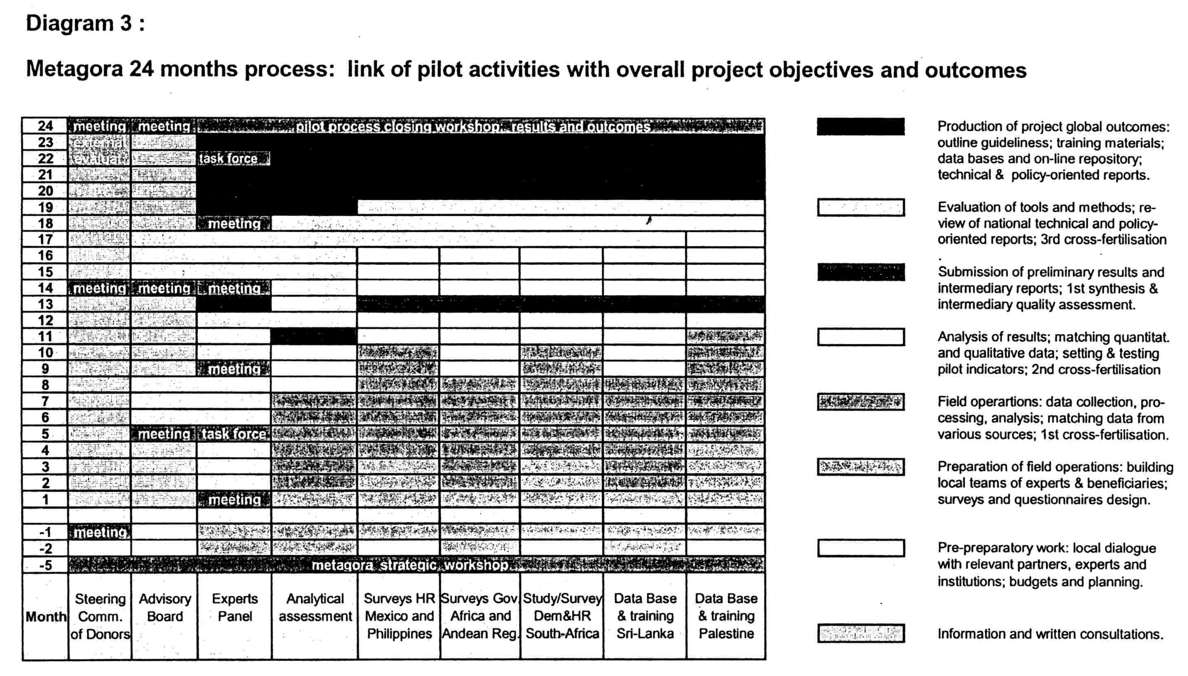
5. EXPECTED OUTCOMES AND FINAL PRODUCTS
5.1 Expected outcomes and impact of the project
METAGORA will:
- produce methods and tools that will allow to obtain data upon which beneficiaries can formulate or evaluate policies;
- increase beneficiaries' knowledge of the state of the art, of the existing expertise on proper DHRG measuring and monitoring methods, as well as of potential use and misuse of indicators;
- give impulse to a structured process of convergence of many different institutional actors towards international agreement and firm adoption of key governance indicators;
- provide the EC and national development agencies with specific measurement methods and generic instruments to be applied throughout a large variety of aid and co-operation programs;
- gather together an unprecedented critical mass of North/South expertness in the field of DHRG assessment methods and therefore increase the potential for interaction and synergies;
- contribute to the expansion of official statistics to the field of DHRG assessment and to enhance the commitment of official statisticians in the establishment of key reliable indicators;
- produce a big multiplier effect both as a global outcome and as a side-effect of its activities.,
5.2 THE METAGORA FINAL PRODUCTS WILL BE:
- A SUBSTANTIVE REPORT PRESENTED IN THE FORM OF "OUTLINE GUIDELINES"
These "Guidelines" will: i) describe the METAGORA process and outcomes and draw global lessons based on the results and confrontation of the various pilot activities, emphasizing both the technical achievements as well as the lessons of the multidisciplinary and participatory processes; ii) provide technical assessment on the solidity and adequacy of methodologies, data collection and analyses used in selected DHRG monitoring mechanisms; iii) propose referenced guidelines for future work in the field, including recommendations on the use and prevention of misuse of quantitative methods and tools; and iv) identify appropriate proper methodologies that can be applied throughout EC programs.
• FIVE NATIONAL AND ONE MULTI-COUNTRY POLICY-ORIENTED REPORTS
These reports will: i) be based on the results of pilot activities, matching quantitative and qualitative approaches; ii) address major national issues and policies of the concerned countries; and iii) focus on selected EC key themes.
• TRAINING MATERIALS
These materials will: i) be based on the training actions conducted in the field as well as on the lessons emerging from the whole METAGORA multidisciplinary and participatory processes; ii) focus on the use and misuse of quantitative methods and indicators; iii) contain a summary of the state of the art, reference frameworks and key literature.
• AN ANALYTICAL INVENTORY OF INITIATIVES AIMING AT MEASURING DHRG
This inventory will: i) contain the findings of the identification and analytical assessment of national and international initiatives aiming at enhancing proper assessment and monitoring methods in the fields of DHRG; ii) include detailed information on current available expertness in the South and the North; and iii) be made public in the form of an on-line repository that will be designed by professionals as a user-friendly research tool
• A PLATFORM FOR INTERNATIONAL AGREEMENT ON GOVERNANCE INDICATORS
This platform will consist both in: i) an informal but effective mechanism gathering together the relevant institutions and experts and ii) a report to be submitted to the UN Statistical Commission presenting conceptual frameworks and a plan of action, including concrete targets and a time schedule, in view to progressive but effective international adoption of standards and key indicators.
5.3 Other expected materials and documents
The expected deliverable items of the work carried out within the various activities are:
Activity 1, Identification and analytical assessment of initiatives aiming at measuring DHRG:
- Database of initiatives, including references of organisations and experts involved;
- Grid of analysis for assessing initiatives;
- Analytical inventory;
- Selected universal bibliography;
- Final activity report.
Activity 2, Mexico:
- Survey datasets;
- Two technical reports on field application of data collection methods and questionnaires;
- Outline proposal for thematic policy-oriented analyses to be addressed to Mexican academic and research centres as well as to NGOs;
- Scientific paper on the methods, implementation and results of the survey, submitted to peer-review for publication in an international statistical review;
- Ad hoc media-oriented material;
- Intermediary and final activity reports.
Activity 3, Philippines:
- Technical report on the questionnaire, data collection method and pre-test.
- Outline project in view to the implementation of pilot human rights survey;
- Ad hoc media-oriented material;
- Intermediary and final activity reports.
Activity 4, Africa and Andean region:
- Rich empirical data bases on several countries which can support original analytical findings;
- At the end of Year 1: report on first results;
- A technical report on surveys;
- Outline proposal for thematic policy-oriented analyses addressed to African and Latin-American academic and research centres as well as to NGOs;
- Scientific paper submitted to peer-review for publication in an international scientific journal;
- Ad hoc media-oriented material;
- Intermediary and final activity reports.
Activity 5, South Africa:
- A survey dataset;
- Scientific paper submitted to peer-review for publication in an international scientific journal;
- Other literature outputs;
- Technical report on survey results;
- Ad hoc media-oriented material;
- Intermediary and final activity reports.
Activity 6, Sri Lanka:
- Preliminary report at the end of Year 1;
- Scientific paper submitted to peer-review for publication in an international scientific journal;
- Ad hoc media-oriented material;
- Final activity reports.
Activity 7, Palestine:
- Dynamic database,
- Outline proposal for thematic policy-oriented analysis, etc.
- Technical report;
- Ad hoc media-oriented material,
- Intermediary and final activity reports.
Support applied research and development of the model for multiple system estimation of totals:
- a computer simulation model to be used in additional research on M-DHRG at later stages;
- a model for use by field investigators who want to estimate the precision of the estimation in a particular situation;
- relevant analytical and application papers, including a Scientific paper submitted to peer-review for publication in an international statistical review;
- Intermediary and final activity reports.
Panel of Experts, technical meetings and final workshop):
- Technical assessments (7 intermediary + 7 final) of the activities and related technical assistance;
- Substantive paper on the platform for progressive adoption of agreed governance indicators;
- Intermediary and final general reports (scientific and technical evaluation of the Project).
Co-ordination Team:
- Several working documents for/ and minutes of the meetings of the Advisory Board;
- Several papers presenting the objectives, development and results of the Project, to be submitted to relevant national and international fora;
- Several working papers on the platform for progressive adoption of governance indicators;
- Project's website and network’s database;
- General policy-oriented report;
- Ad hoc media-oriented material;
- Project's final workshop conclusions;
- Intermediary and final general reports.

6. THE ORGANISATION
A. Identity

Full legal name  (official name): | Organization for Economic Co-operation and Development
Acronym (where applicable): | OECD
Legal status: | International Organisation
VAT registration number  (where applicable): | 775 687 957 00016
Official address: | 2, rue André-Pascal, 75775 Paris Cedex 16 (France)
Headquarters location, if
different from official address
Postal address:
Contact person: | Antoine Simonpietri
Telephone n° : | (33-1).45.24.90.51/16.22
Fax n°:  . | (33-1).45.24.94.05
E-mail address: | Antoine.simonpietri@oecd.org
Website: | www.paris21.org

B. Bank details
The bank must be in the country in which the organization is registered.

Account name: | OECD
Bank account no: | 00010070747 21
Bank code: | 3004 00892
SWIFT code: | BNPA FR PP PKL
Bank name: | BNP PARIBAS
Bank address: | 51, avenue Kléber, 75016 Paris, France
Name(s) of signatory(ies): | 1.) Jim Worrel,/2.)Bill Marvin
Position(s) of signatory(ies): | 1.) Head of Division, Treasury/2.)Treasury Reporting Mgr.

ANNEXES:

A) LOGICAL FRAMEWORK
B) MATRIX OF TASKS AND POSTS OF THE CO-ORDINATION TEAM

A) LOGICAL FRAMEWORK

 |  | Intervention logic |  | Objectively verifiable indicators of  achievement |  | Sources and means of  verification | Assumptions
Overall objectives |  | 1. Strengthening democracy, human rights and governance (DHRG). |  | 1. Effective generation of evidence-based and policy-oriented information, -analysis and evaluation of DHRG. |  | 1. Evidence-based reports and documents of official bodies HR institutions and civil society on DHRG progress | - Political and social contexts allow development of participatory democracy and progress in 1-'R implementation; there is an effective
 |  |  |  |  |  | , | political will to monitor
 |  | 2. Addressing national and international needs for policy-oriented information on DHRG for policy |  | 2. Establishment of national and international mechanisms aiming at |  | 2. National and international  policy papers, guidelines and  manuals aiming at enhancing  evidence-based monitoring  tools, methods and mechan- isms. | implementation Plementation and im pact of policies.
 |  | makers and civil society actors, and for aid |  | assessing progress of DHRG through  evidence-based tools matching  quantitative and qualitative information;  international agreement/on indicators,  standards and methods allowing  comparability of information over time  and space.
 |  | programming and monitoring. |  |  |  |  | - Beyond the project's funding,
 |  |  |  |  |  |  | international and local financial
 |  |  |  |  |  |  | resources are available for policies
 |  |  |  |  |  |  | and programs aiming at enhancing
 |  |  |  |  |  |  | DHRG and at producing related
 |  |  |  |  |  |  | relevant information.
 |  |  |  |  |  |  | - Complementary types of actions are
 |  |  |  |  |  |  | undertaken simultaneously to
 |  |  |  |  |  |  | strengthen DHRG.
Project |  | Enhancing human rights reporting, governance |  | 1. Coverage (extensiveness), assessment |  | 1. On-line analytical inventory of | - Political stability and security allow
purpose |  | evaluation and assessment of democracy by: |  | (typology, quality) and usefulness of the |  | current work and initiatives on | the conduct of field operations.
 |  | 1 . Identifying and assessing current work and initiatives |  | information provided on current work and initiatives. |  | measuring DHRG. | - Dependence on external actors
 |  | undertaken in the North and the South in view to |  |  |  |  | whose collaboration is needed for
 |  | measure DHRG and to build indicators of |  | 2. Relevance, reliability and applicability |  | 2. Intermediary and final | the implementation of some key
 |  |  |  | (potential of replication and extension) of |  | reports of and Experts | activities (surveys, data bases,
 |  | 2. Developing and testing proper methods and tools to |  | the tools and methods developed, tested |  | Panel; mins minutes of the | analysis and studies) does not
 |  | obtain relevant information on DHRG upon which |  | and evaluated throughout the project. |  | Advisory Board. | impede projects running.
 |  | national and international actors can formulate and
 |  | evaluate policies. policies. |  | 3. Inclusiveness, participation, cross-fertilization and interaction within and |  | 3. Project's local and global reports on the working processes. | - All relevant actors are associated in project's activities and bodies at the
 |  | 3. Facilitating, fostering and deepening participatory |  | between the projects pilot actions as well as between the project's local and |  |  | local and at the global levels (participatory process).
 |  | processes, multi-disciplinary collaboration and |  | Global working processes. |  | 4. Final products (in the project's
 |  | synergies between experts, actors and sectors |  |  |  | website) and other related | - Relevant IOs and NGOs accept to
 |  | involved or strongly interested in proper evidence- |  | 4. Relevance, usefulness and user- |  | documents on project's results. | exchange views a and to work
 |  | based monitoring g of DHRG. |  | friendliness of the guidelines and other final products. |  |  | together on indicators' issues.
 |  | 4. Providing outline guidelines, pilot policy-oriented |  | 5. Effective advancement of agreement |  |  | - Experts and actors build on (good
 |  | reports and training materials on evidence-based |  | between experts and institutional actors |  | 5. Report of the project's task | and bad) lessons from previous
 |  | DHRG assessment. |  | on key concepts and standards; |  | force on governance | attempts to develop agreed
 |  | 5. Proposing a conceptual framework and an operational |  | formulation of a plan of action (including |  | indicators to the UN Statistical | standards and indicators for
 |  | platform for progressive international agreement on |  | concrete targets and a work schedule); |  | Commission and follow-up | measuring DHRG.
 |  | measurable concepts, assessment standards and key |  | impact on international fora discussing |  | action of this Commission.
Expected |  | A) Outputs / final products : |  | For all products: - |  | For all products: | - Unhindered conduct of pilot
results |  |  |  |  |  |  | operations is pre-condition to
 |  | 1. On-line analytical inventory of initiatives aiming at |  | 1-5.1: Effective delivery of expected |  | 1-5.1: Final products | effective delivery (c.f. below)
 |  | measuring DHRG, including detailed information on |  | products.
 |  | existing expertness. |  |  |  | 1-5.2: Planned deadlines.
 |  |  |  | 1-5.2: Conformity of delivery to timetable.
 |  | 2. Five national and one multi-country policy-oriented |  |  |  | 1-5.3:-.Experts Panel reports.
 |  | reports based on the results of pilot activities, |  | 1-5.3: Effective quality assessment.
 |  | addressing major national issues and focusing on |  |  |  | 1-5.4: Minutes of Advisory Board
_ |  | selected EU key themes. |  | 1-5.4: Meeting needs and reaching |  | meetings and closing workshop
 |  |  |  | expectations of beneficiaries. |  | (conclusions).
 |  | 3. Training materials on the use and misuses of
 |  | quantitative methods and indicators in the field of |  | For single products: |  | For single products:
 |  | DHRG assessment.
 |  |  |  | 1.1: Coverage of the analytical assessment. |  | 1.1: Number, interest, quality,  variety and geographical  distribution of identified  initiatives.
 |  | 4. Substantive report describing the METAGORA
 |  | process and outcomes, and proposing "Outline |  | 1.2: Interest and use of the analytical
 |  | Guidelines" on proper methodologies that can be |  | inventory. |  |  | -
 |  | applied throughout national, bilateral and EC programs.
 |  |  |  | 2.1: Direct impact in public policies and |  | 1.1: Number and frequency of
 |  |  |  | political agendas. |  | individual accesses to the on-line
 |  | 5. Platform for international agreement on governance indicators, including recommendations, a plan of action and a schedule of work. |  | 2.2: Accessibility of final results, databases and datasets from pilot field operations. |  | inventory.  2.1: Reaction to/ and follow-up of pilot activities and related reports
 |  |  |  |  |  | by national official bodies
 |  |  |  | 3: Interest and user-friendliness of training |  | (declarations, decisions), civil
 |  |  |  | materials. |  | society (interventions, proposals)
 |  |  |  |  |  | and the media (comments).
 |  | - |  | 4.1: Relevance of lessons from local pilot
 |  |  |  | activities and their potential impact |  | 2.2: Public reports and
 |  |  |  | '(extension and replication) at the global |  | accessible data bases (including
 |  |  |  | level. |  | data and metadata).
 |  |  |  | 4.2: Relevance and usefulness of the |  | 3: Training tests with users.
 |  |  |  | guidelines for national, bilateral and EC
 |  |  |  | programs. |  | 4.1: Minutes of Advisory Board
 |  |  |  |  |  | meetings and closing workshop
 |  |  |  | 5: Impact in the international community and in EC instances. |  | (conclusions).
 |  |  |  |  |  | 4.2: idem
 |  |  |  |  |  | 5. Follow-up of the platform by
 |  |  |  |  |  | the UN Statistical Commission
and other relevant UN and EC
instances.
Expected |  | B) Effects / impact
results |  | 6. Increased knowledge of beneficiaries on the state of |  | 6.1: Application of previously unknown or |  | 6.1: Relevant policy papers and
 |  | the art in DHRG measuring and monitoring methods. |  | underused methods in measuring and |  | reports assessing DHRG issues.
 |  |  |  | monitoring DHRG.
 |  | 7. Enhanced national and international capacities to |  | 6.2: Effective change in assessment |  | 6.2: idem
 |  | produce and use evidence-based information on |  | patterns within DHRG reporting of |  | 7.1: New specific surveys and
 |  | DHRG and, on this basis, to formulate and evaluate |  | beneficiaries. |  | databases.
 |  | key policies. |  |  |  | 7.2: New specific national and
 |  |  |  | 7.1: Collection and analysis of relevant |  | international DHRG policy
 |  | 8. Deepened North/South community of experts and |  | quantitative and qualitative data on DHRG. |  | papers and evaluation tools.
 |  | actors involved in DHRG assessment, gathering a
 |  | critical mass of expertness and therefore increasing |  | 7.2: Application of evidence-based |  | 8.1: Project's database.
 |  | synergies and interaction at the national and global level. |  | information on DHRG in the formulation and evaluation of policies. |  | 8.2: Number and types of mutual
 |  |  |  |  |  | exchanges, institutional twinning
 |  | 9. Greater skills in DHRG measurement and evaluation, |  | 8.1: Expansion of North/South network of |  | and new joint projects.
 |  | applied in national policy design as well as in EC aid |  | experts and institutions involved in the |  | 9.1: Policy papers, new project
 |  | and co-operation programs. |  | project. |  | documents and working
 |  |  |  |  |  | programs.
 |  | 10. Initial international consensus on a set of basic |  | 8.2: Increased exchange of knowledge |  | 9.2: EC evaluation reports,
 |  | measurable concepts and key indicators in the field of governance. |  | about and experiences with statistical tools and methods in the field of DHRG. |  | programs and policy papers.
 |  |  |  |  |  | 10.1: Agendas and minutes of
 |  | 11. Expansion of statistical analysis to new fields of DHRG |  | 9.1: Reference to project's findings in |  | meetings and conferences of the
 |  | monitoring and introduction of DHRG issues into the |  | policies and programs. |  | international statistical community.
 |  | national and international agendas and working
 |  | programs of official statistics. |  | 9.2: Effective evidence-based evaluation of specific EC aid and co-operation programs. |  | 10.2: Reports of the UN statistical commissions and other
 |  |  |  |  |  | relevant UN and EC bodies.
 |  |  |  | 10.1: Discussion of project's findings in the
 |  |  |  | international statistical community. |  | 11.1: Peer-reviewed papers and
 |  |  |  |  |  | studies in authoritative scientific
 |  |  |  | 10.2: Agreed measurable concepts and key indicators in the field of governance. |  | journals and statistical reviews.
 |  |  |  | 11.1: Impact of project's findings on |  | 11.2: National and international
 |  |  |  | international statistical community. |  | statistical programs.
 |  |  |  | 11.2: Commitment of national and
 |  |  |  | international statistical services to produce
 |  |  |  | relevant statistics to assess DHRG.
Activities
 |  | A) Pilot activities: |  | For all pilot activities: |  | For all pilot activities:
 |  | 1. Survey-based HR diagnosis and monitoring in Mexico |  | 1-7.1: Execution and delivery on schedule. |  | 1-7.1: Deadlines for surveys,
 |  | 2. Survey-based HR diagnosis and monitoring in the |  | 1-7.2: Available documentation on the |  | production of databases, and
 |  | Philippines. |  | process and technical protocols on field |  | delivery of technical notes and
 |  |  |  | operations and analytical work. |  | policy-oriented reports.
 |  | 3. Monitoring democracy and governance through household surveys in Western Africa and in the Andean Community. |  | 1-7.3: Technical rigor of field operations and quality of data processing and statistical analysis. |  | 1-7.2: Minutes of local meetings,
 |  |  |  | 1-7.4: Relevance of policy-orientation and |  | working documents, papers on
 |  | 4. Survey-based auditing of D and HR in the context of |  | direct impact on targeted policies. |  | survey design, questionnaires,
 |  | land reform in South Africa. |  | 1-7.5: Inclusiveness and participation of |  | databases.
 |  |  |  | local beneficiaries and relevant players. |  | 1-7.3: Local technical reports,
 |  | 5. Quantitative analysis and records on HR violations in |  | 1-7.6: Mutual synergies, interaction and |  | reports of expert's missions and
 |  | Sri Lanka. |  | cross-fertilization. |  | evaluation of the Panel of
 |  | 6. Dynamic database on D and HR and pilot indicators of |  | 1-7.7: Degree of replication and extension. |  | Exerts. Experts.
 |  | progress in Palestine. |  |  |  | 1-7.4: Policy-oriented reports and
 |  | 7. Supporting research and development of a model of |  |  |  | reaction from authorities, media,
 |  | multiple system estimation of totals. |  |  |  | etc.
 |  |  |  |  |  | 1-7.5: Number, variety and
 |  |  |  |  |  | relevance of actors involved in
 |  |  |  |  |  | activity; minutes of local and
 |  |  |  |  |  | regional consultation meetings,
 |  |  |  |  |  | agendas and lists of attendants.
 |  |  |  |  |  | 1-7.6: Number of cross
 |  |  |  |  |  | supporting missions of PIOs'
 |  |  |  |  |  | experts; reference in activity
 |  |  |  |  |  | reports to lessons from others'
 |  |  |  |  |  | experiences; Panel of Experts'
 |  |  |  |  |  | evaluation of mutual exchanges
 |  |  |  |  |  | between PIOs..
 |  |  |  |  |  | 1-7.7: Outline guidelines;
 |  |  |  |  |  | Advisory Board's final evaluation;
 |  |  |  |  |  | national demands for technical
 |  |  |  |  |  | assistance in view to replication.
Activities
 | B) Cross-cutting activities, synthesis and production
 | of global lessons: |  | 8. Universal approach and sound |  | 8. On-line inventory, analyti
 | 8. Identification and analytical assessment of initiatives |  | analytical process of identification |  | cal grill, questionnaire.
 | aiming at measuring progress in the field of DHRG. |  | and assessment. |  | 9. Working documents and
 | 9. Establishment of a conceptual and operational |  | 9. Active contribution of relevant experts |  | minutes of the Task Force
 | platform for adoption of internationally agreed |  | and major international actors to the |  | meetings.
 | governance indicators. |  | formulation of an agreed platform.
 | 10. Synthesis of projects achievements and production of outline guidelines. |  | 10. Interaction and collective commitment of experts within the bottom-up synthesis process |  | 10. Working documents and minutes of Experts Panel.
 |  |  | .
 | C) Co-ordination and steering activities
 | 11. Project Co-ordination Team: overall management, |  | 11. Operational leadership: management, |  | 11. Intermediary and final project
 | support and co-ordination activities. |  | organization, information, advocacy. |  | reports; internal project's
 | 12. Panel of Experts: technical meetings, scientific |  | 12. Substantive leadership: cohesion of |  | evaluations.
 | reporting and evaluation of project's outcomes, |  | project process, quality control, |  | 12. Minutes of Panel's meetings,
 | provision of technical assistance to PIOs. |  | restitution of know-how, fostering |  | technical reports and internal
 |  |  | partnership. |  | project's evaluations.
 | 13. Advisory Board: consultations and meetings and
 | provision of advice and guidance. |  | 13. Policy-oriented advice, guidance and |  | 13. Minutes, reports and final
 | 14. Steering Committee of Donors: reviewing the |  | evaluation. |  | evaluation of Advisory Board.
 | advancement and results of the project, providing |  | 14. Steering and controlling of the project |  | 14. Minutes of the Steering
 | support and guidance. |  | process. |  | Committee.
 | 15. Closing workshop: Presentation of results and final |  | 15. Synthesis and final evaluation of the
 | products and orientations for further concrete action. |  | project; operational conclusions in view |  | 15. Minutes and conclusions of
 |  |  | to the follow-up. |  | the closing workshop.

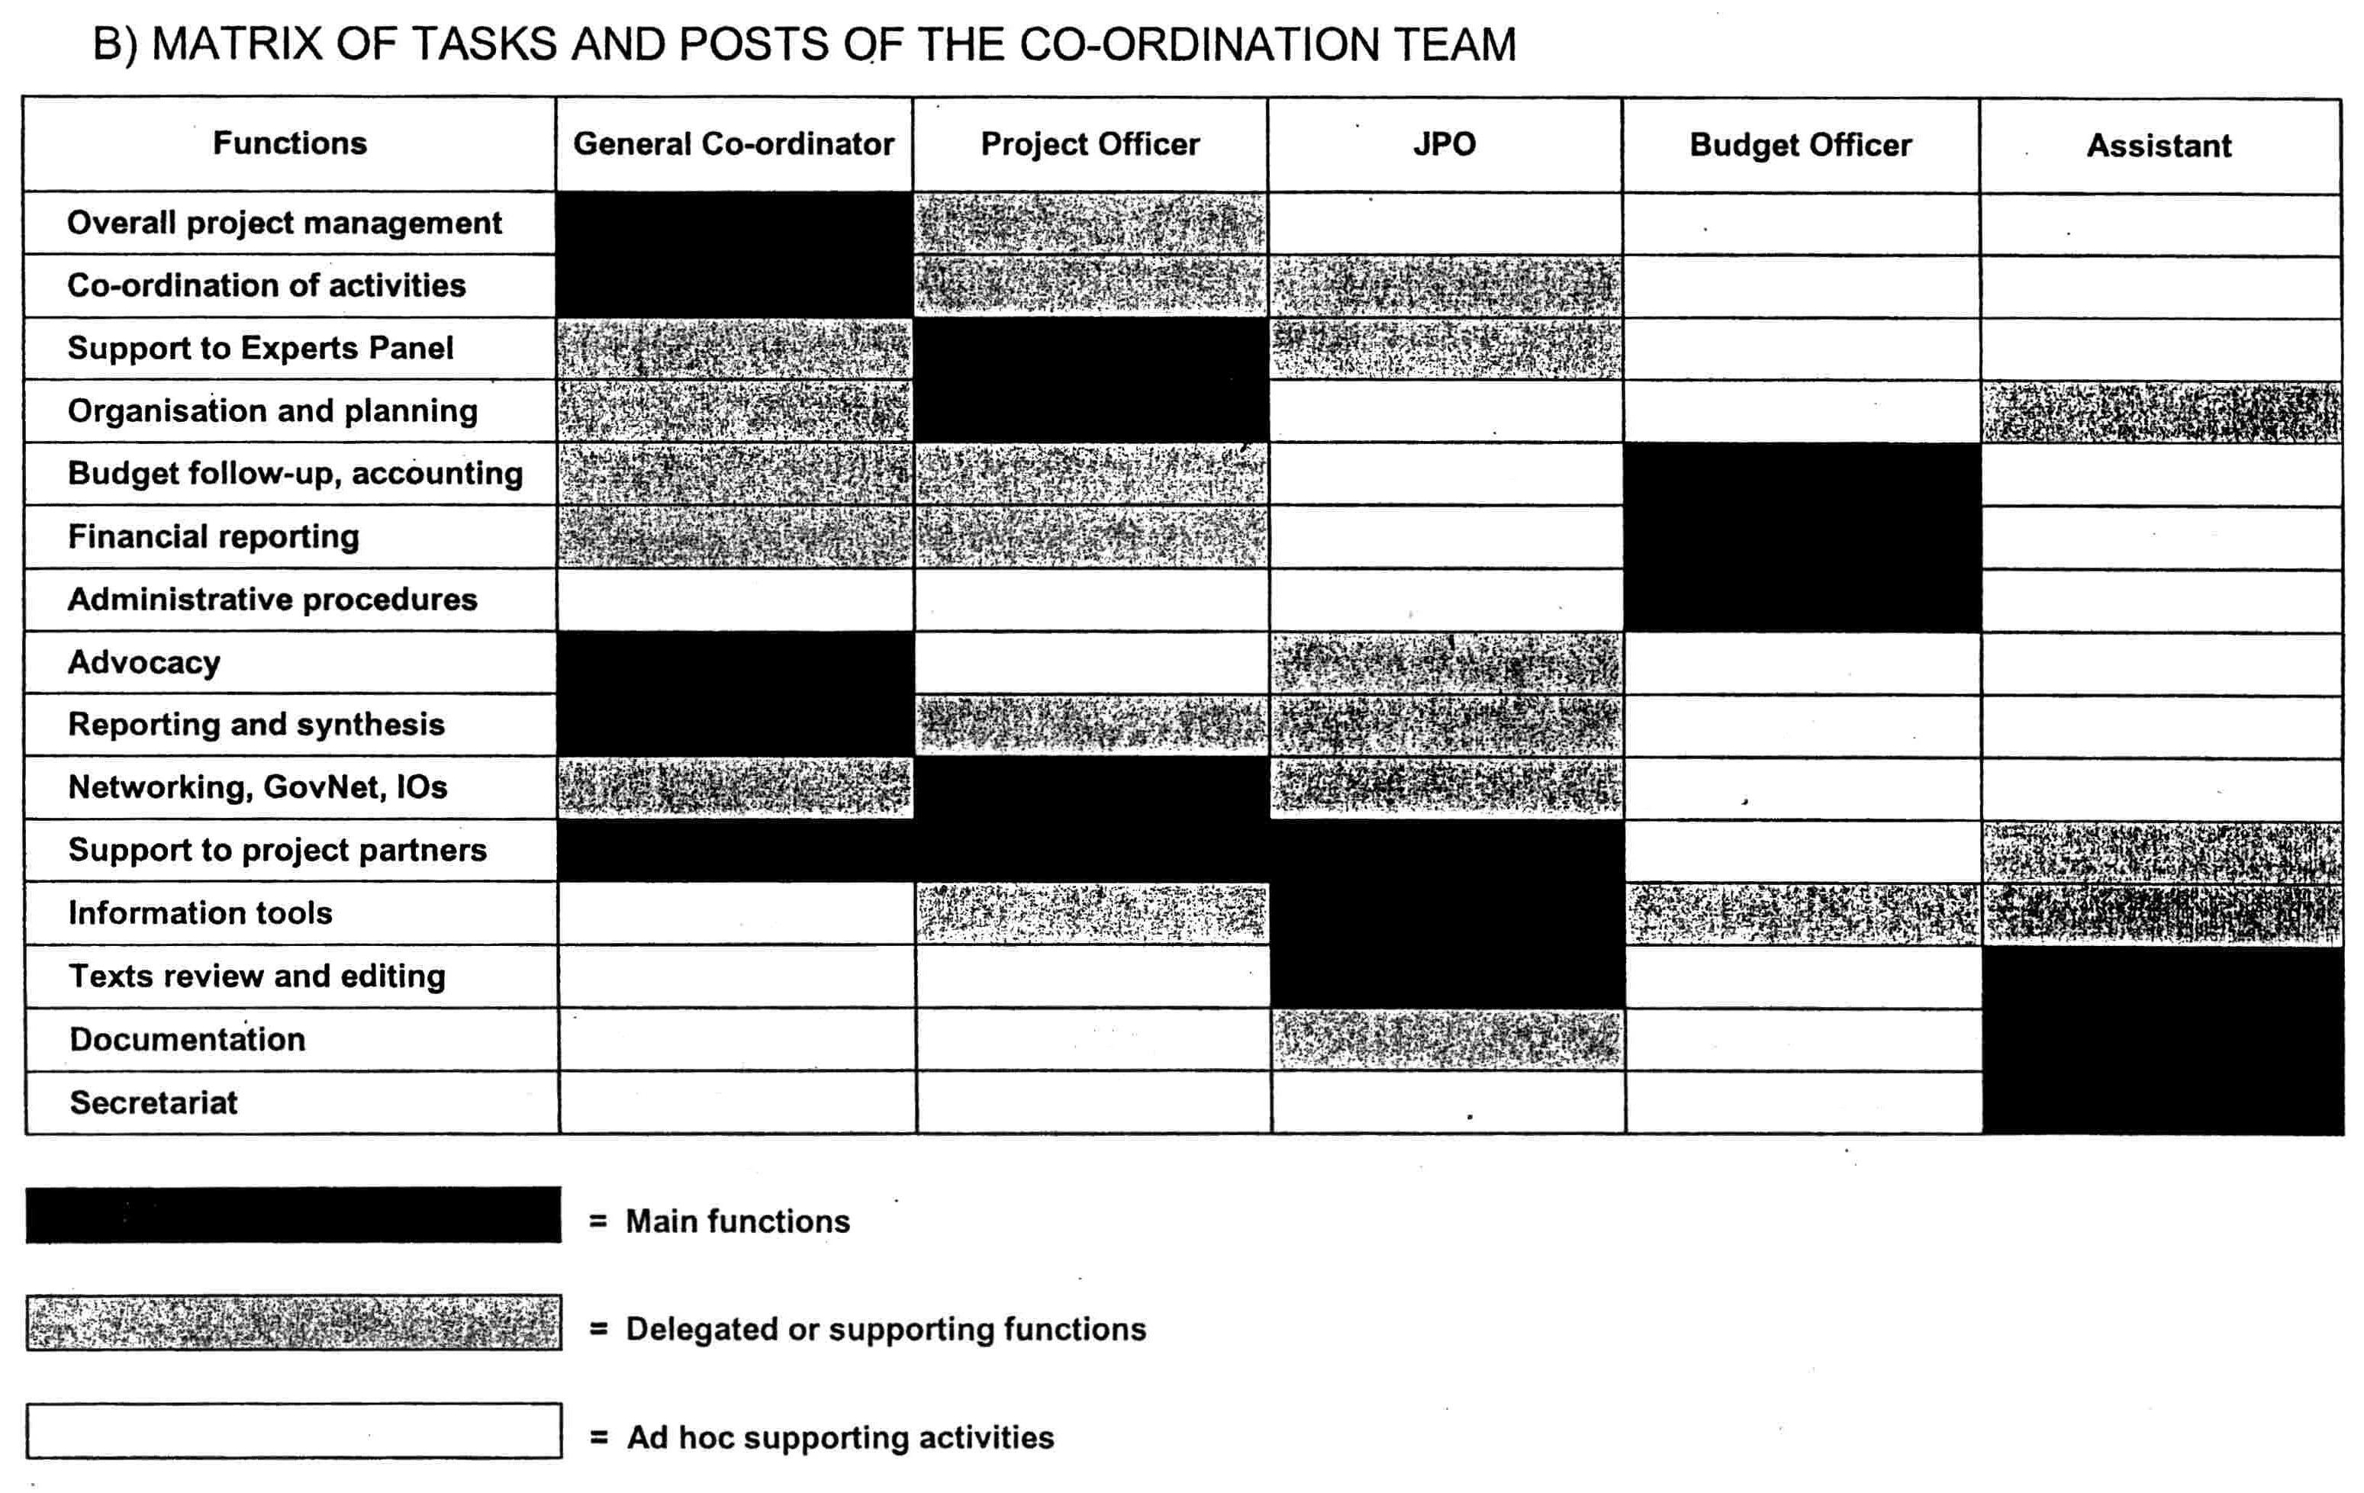
ANNEX IV - FINANCIAL REPORTING REQUIREMENTS
1. Eligible costs
To be considered eligible as direct costs under this Agreement, costs must:
- Be necessary for carrying out the activities foreseen in Annex I, be provided for specifically in this Agreement and comply with the principles of sound financial management, in particular value for money and cost-effectiveness;
- Have actually been incurred during the implementation period of this Agreement as defined in Article 3.2;
- Be recorded in the Partner organisation's accounts, be identifiable, backed by originals of supporting evidence, and verifiable.
The following direct costs may be eligible:
- The cost of personnel assigned to the activities foreseen in Annex I (including social security charges, direct taxes paid for the employees and other remuneration-related costs);
- Travel and subsistence costs for staff taking part in the activities foreseen in Annex I, provided they do not exceed those normally borne by the Partner organisation;
- Purchase costs for equipment which are attributable to the activities foreseen in Annex I;
- Purchase costs for goods and services (transport, storage and distributing, etc) which are directly attributable to the activities foreseen in Annex I;
- Costs of consumables and supplies directly attributable to the activities foreseen in Annex I;
- Costs deriving directly from the requirements of this Agreement (dissemination of information, translation, reproduction, rent of conference room, targeted training, etc).
The following costs shall not be considered eligible:
- Debts and provisions for possible future losses or debts;
- Interests owned by the Partner organisation to any third party;
- Items already financed from other sources;
- Currency exchange losses;
- Taxes, duties and charges (such as VAT, custom duties, etc).
2. Supporting documentation
Direct costs should be backed by the following original supporting documents:
(a) Personnel costs
- Timesheets following the attached model
The timesheet is used for registering the days actually worked. The staff member shall put a tick against the days actually worked and indicate for each day worked the place of performance of the work. A maximum of 22 working days may be registered per calendar month.
(b) Travel expenses
- Invoice issued by the travel agency,
- Used flight ticket stub and boarding passes,
- Used train ticket,
- Taxi receipt,
- Any other type of receipt depending on the means of transportation used.
(c) Purchase of equipment or supplies
- Invoice from the company which sold the equipment or supplies.
(d) Purchase of services
- Invoice or receipt issued by the company or consultant
3. Model of financial report
The financial report shall be composed of two tables:
Table 1 - Summary table following the same format as the one used for the presentation of the budget as set out in Annex II,
Table 2 - Table per budget line detailing all actual expenditure incurred,
An example of financial report is provided hereafter.
Please note that only expenses incurred within the prescribed period for execution of the agreement may be included as actual expenditure.

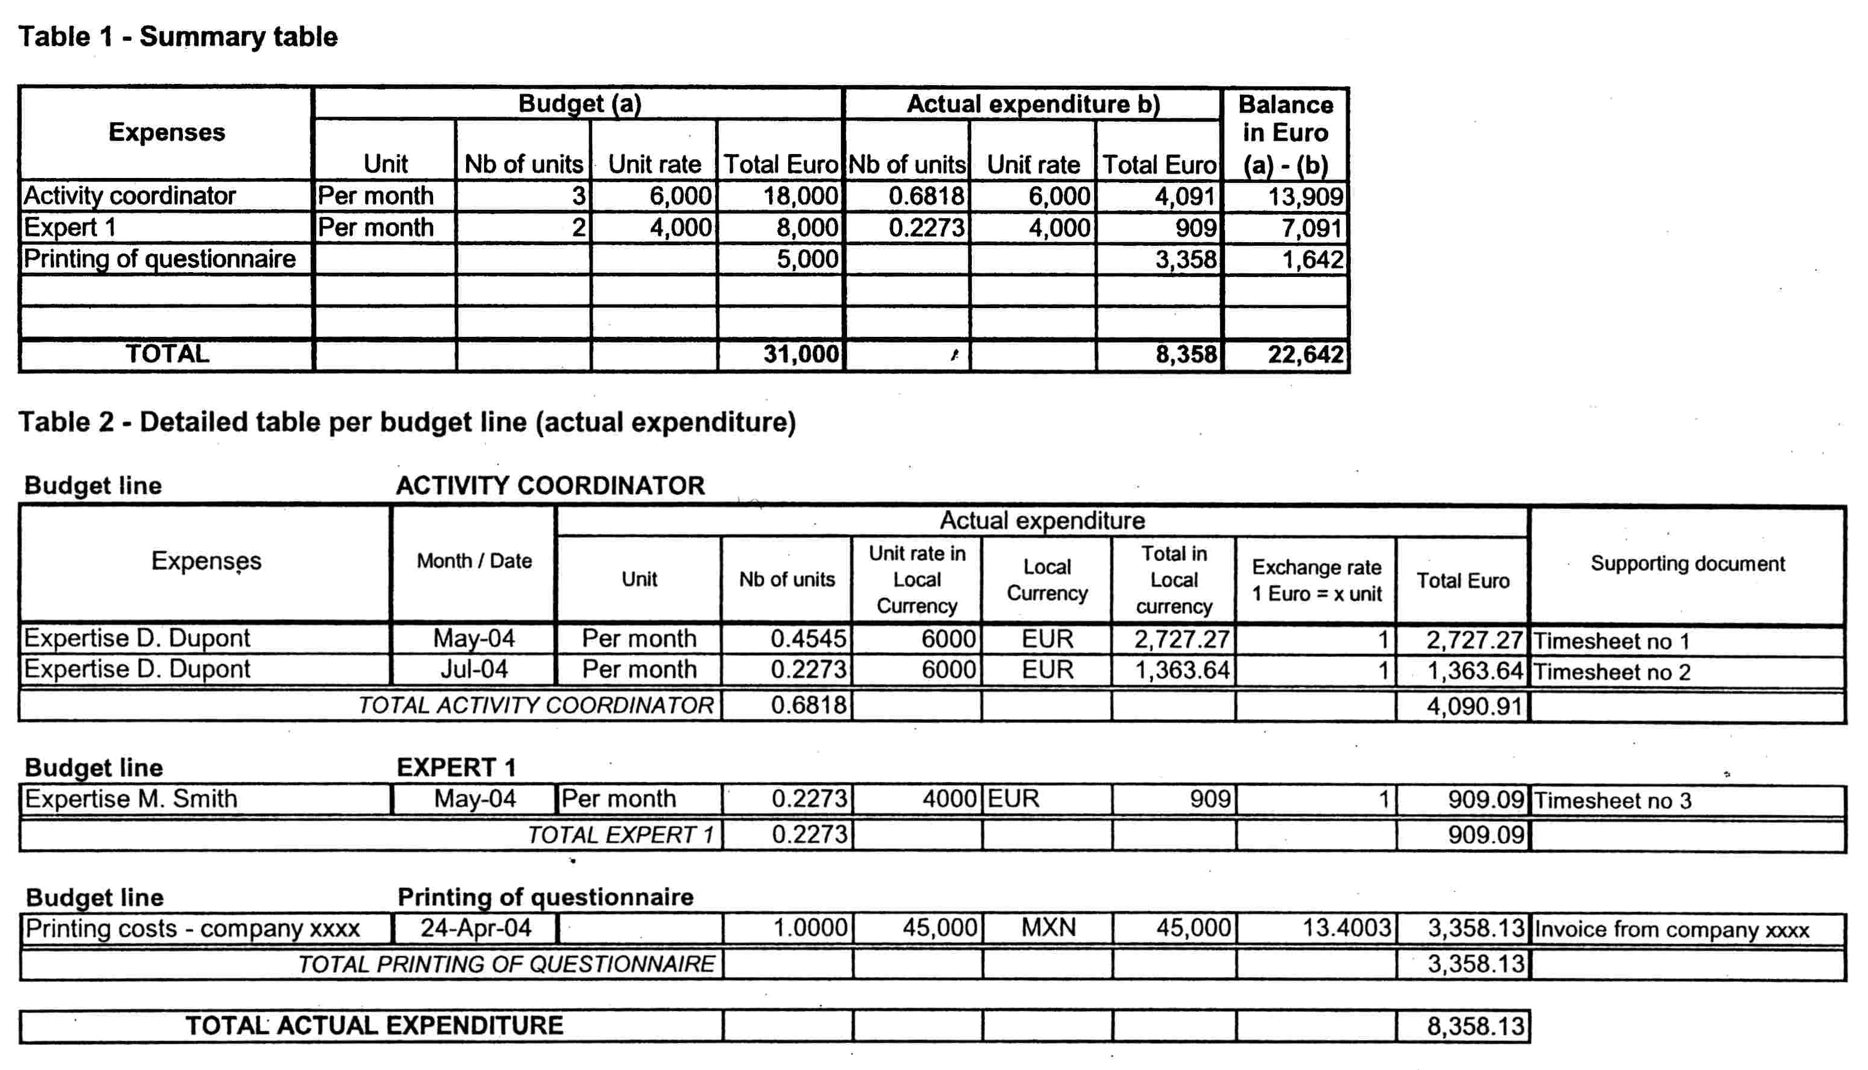
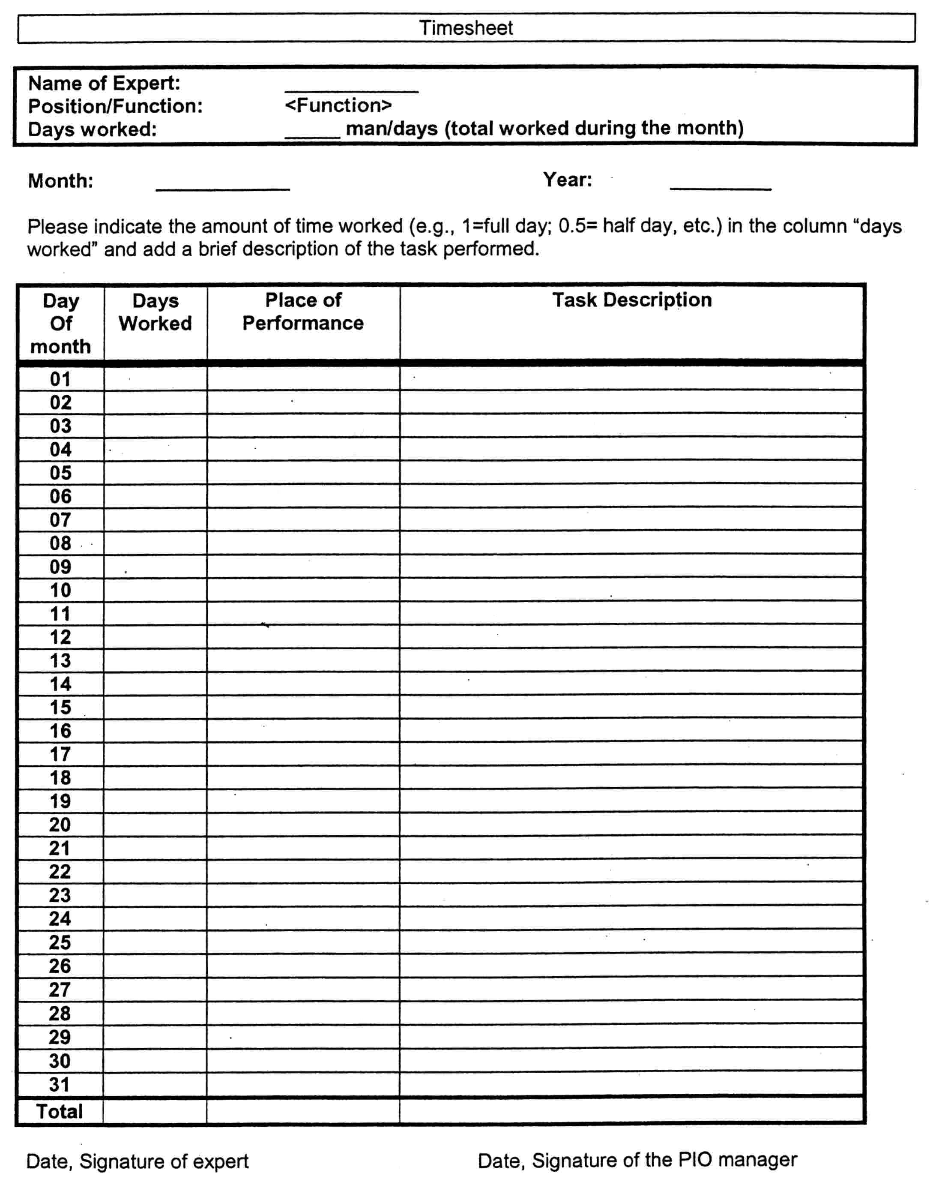
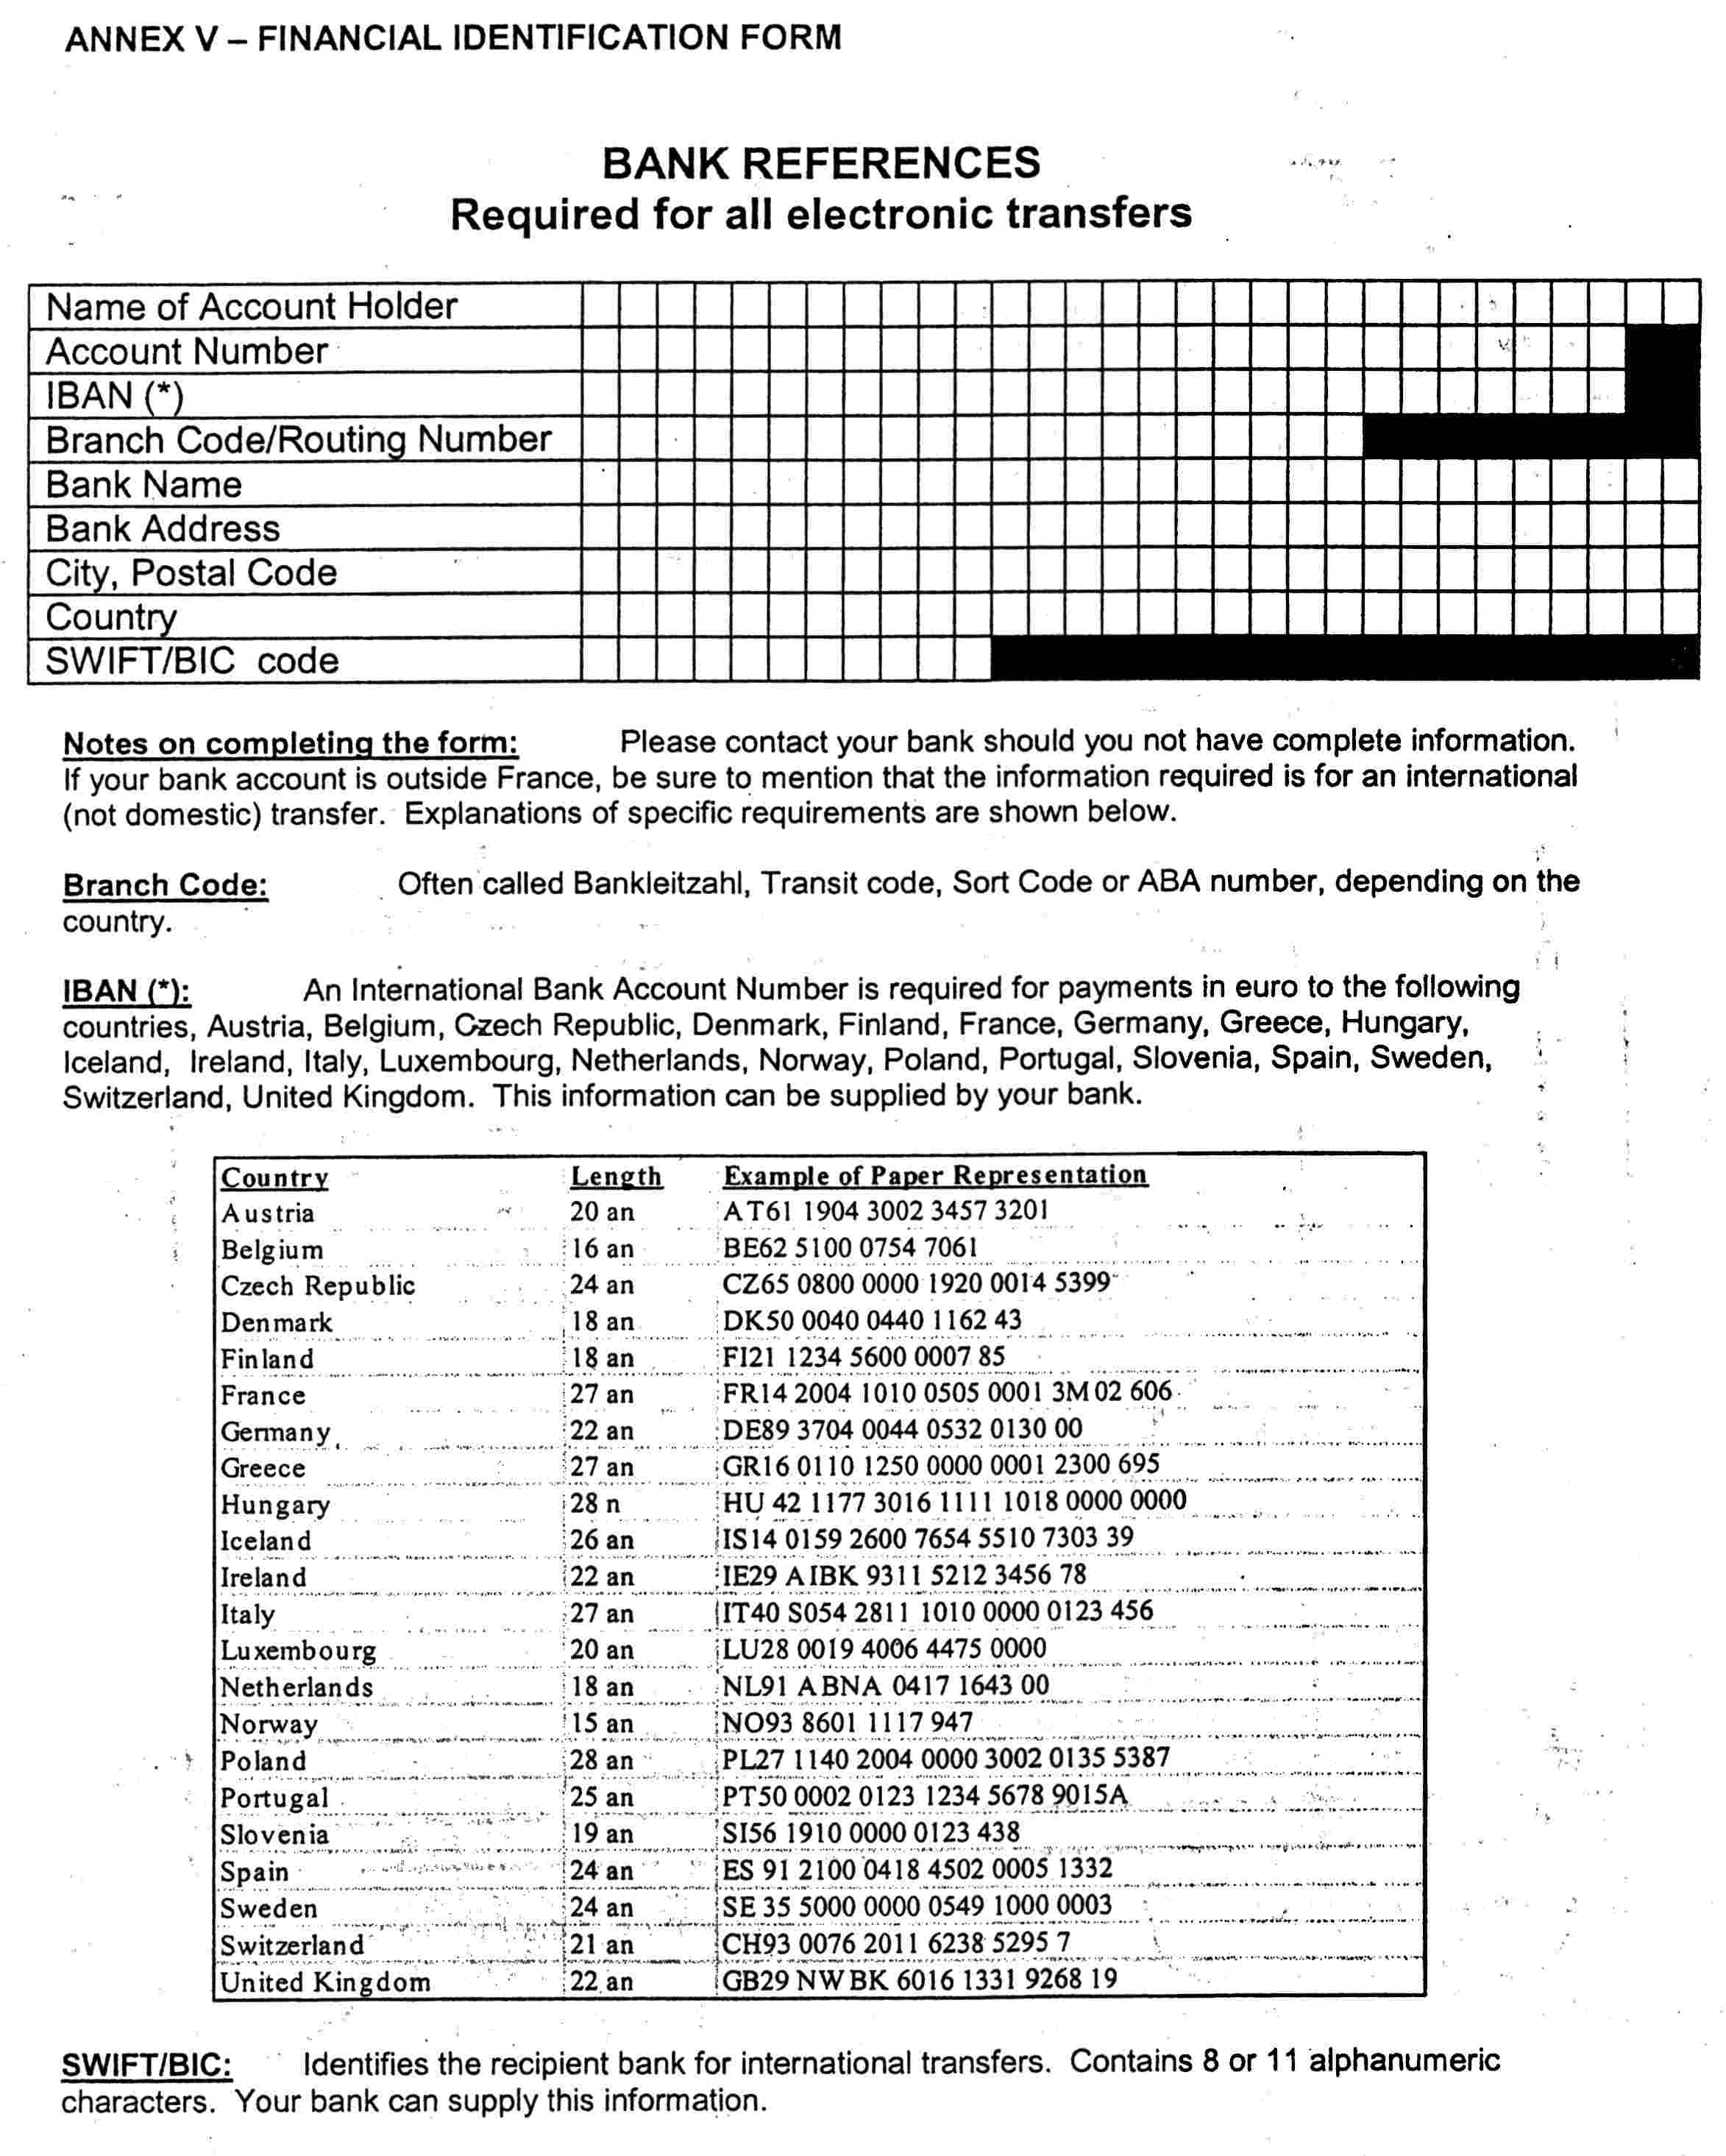

* * * * *

National household survey on living conditions; includes the modules of subjective poverty, governance and democracy.
Given the pilot character of the implementation, the questionnaires are not completely identical. Furthermore, some questions have to be adapted to the specific circumstances in each country.
Subjective Poverty" applied in all households, "Governance" and "Democracy" in 3500 households.
Moreover, the Swiss Federal Department of Foreign Affairs is contributing in kind to METAGORA with the secondment of a Junior Professional Officer to the project's co-ordination team. The secondment of this JPO position is financed by the JPO/Associate Expert Program of the Swiss Expert Pool for Civilian Peace Building (SEP). As the incumbent will be selected, contracted and directly paid within the framework of SEP, the salary costs of this position are neither considered in the financing schema, nor included in the METAGORA budget.
Report submitted by the Human Development Report Office of the United Nations Development Program to the 33rd session of the UN Statistical Commission (3-8 March 2002), document E/CN.3/2002/27; see §30.d.
Report of the Friends of the Chair of the Statistical Commission on an assessment of the statistical indicators derived from United Nations summit meetings, submitted to the 33^{b} session of the UN Statistical Commission (3-8 mars 2002), document E/CN.3/2002.26. See §4, § 65 and §107.11.
Statistics and indicators in the fields of human rights and governance: The 2000-2003 follow-up of the Montreux Conference on statistics, development and human rights", room document submitted by Switzerland to the 34^{m} session of the UN Statistical Commission (4-7 March 2003). This document was made public by the UN Secretariat in Its Internet site: http://unstats.un.org/unsd/statcom/docO3/montreux.pdf
Pads21 was initially launched in 1999 as a joint OECD / World Bank / IMF / EC initiative. Hosted by OECD, this world-wide Consortium is a partnership of policymakers, analysts and statisticians, and its members are from governments, international organisations, professional bodies, and academic institutions. It acts as a catalyst for promoting a culture of evidence-based policymaking and monitoring in all countries, and especially in developing countries. The role of PARIS21 is to foster more effective dialogue among these stakeholders and to reinforce statistical capacity as foundation for effective monitoring of poverty alleviation policies. The Paris21 secretariat, based at OECD in Paris, manages a pluri-annual budget of 4,8 millions US dollars for developing large projects around the world, aiming at facilitating regional and national conferences, supporting country-based activities and animating subject matter task teams (see www.oaris21.ora for more information).
When required by the local tax regulations, original documents may be replaced by copies. In this case, original documents shall be archived by the Partner organisatión until at least 7 years after the end of the implementation period of the present Agreement. During that period, the OECD or any mandated body may undertake, including on the spot, checks related to the activities foreseen in Annex I and financed under the present agreement.

